Screen shots for the MONTHLY closing stock entries
Where the company desires to put the closing stock in the ERP, every month

Monday, October 24, 2011

First screen –
This is the first April 2011 position
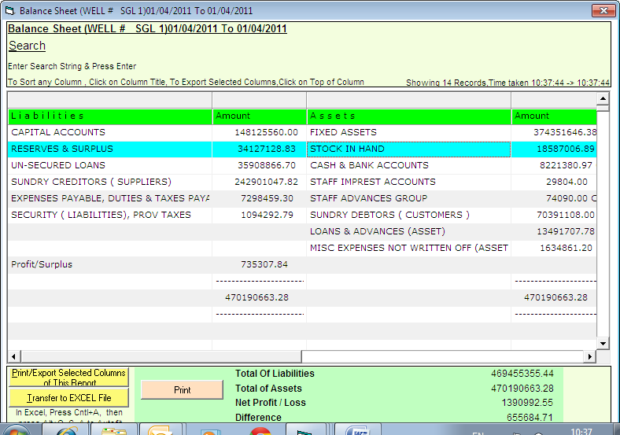

This was a stock as on 31.3.2011
For April end
opening stock | 18587006
closing stock | 22587006
inc dec in stock | 4000000

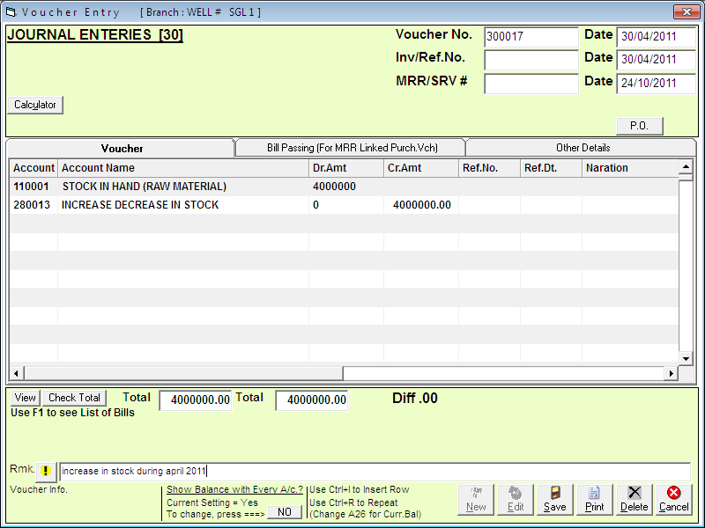

This entry is done
So,
Action is reflected in balance sheet and profit and loss account as required

in balance sheet, stock comes to correct position

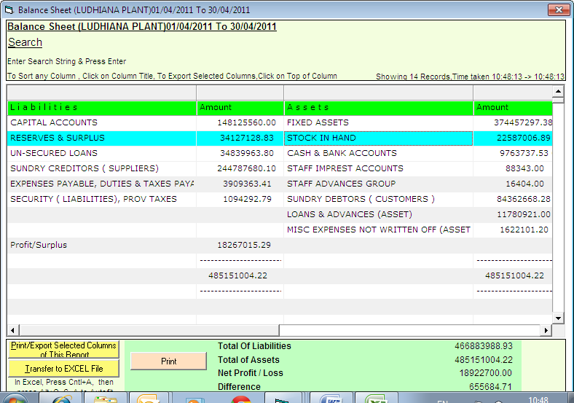

And in P & L account
The stock comes to correct position too

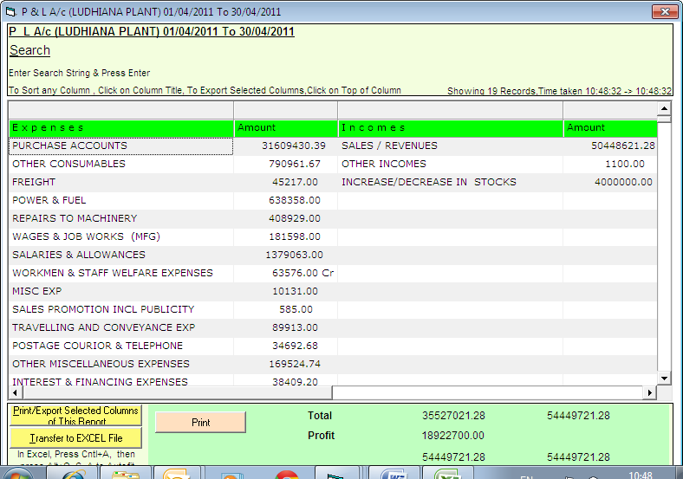

Now, we review for May 2011
Again stock gets increased

opening stock | 22587006
closing stock | 24112006
inc dec in stock | 1525000

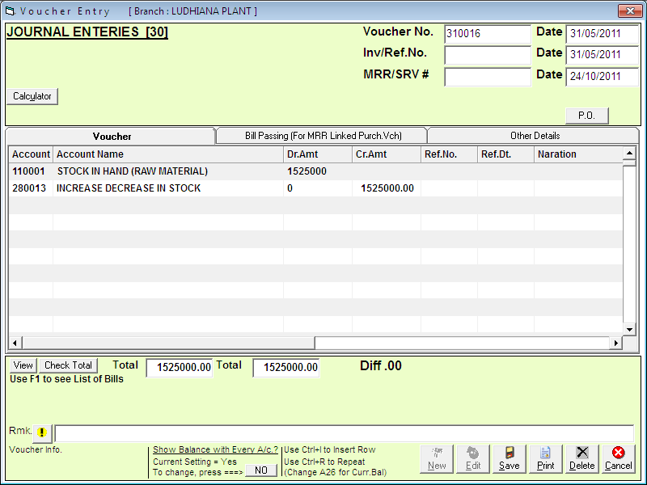

This JV entry is done
For the “increase value” only

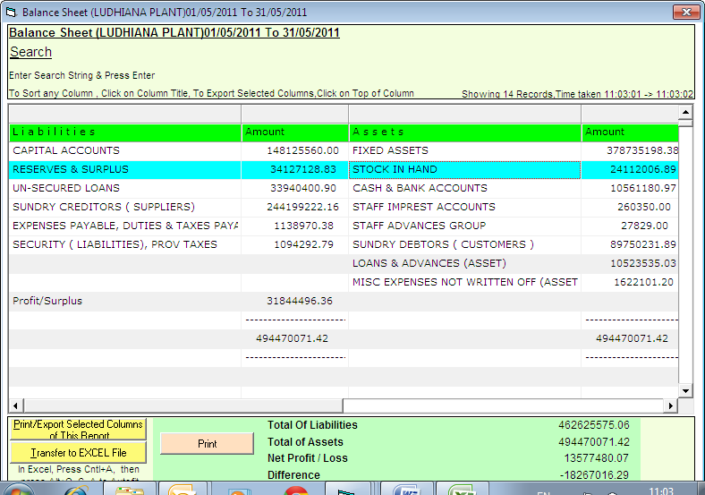

Balance sheet is ready

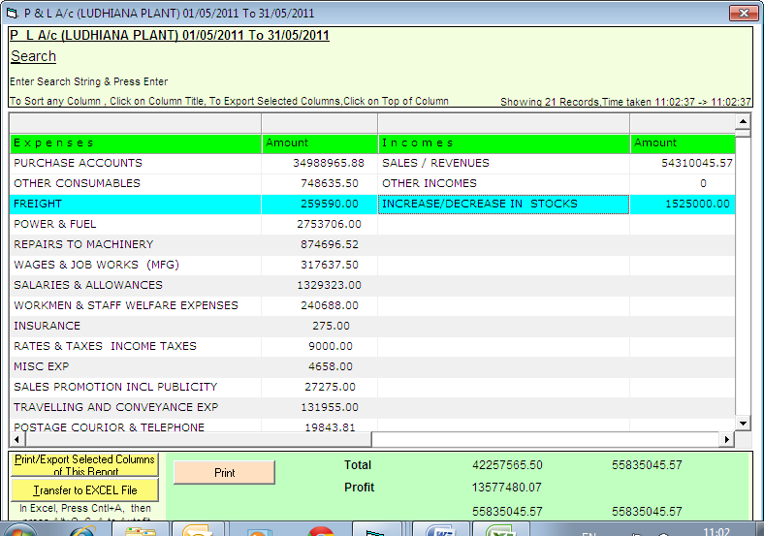

P & L Account is also ready

Next example will show you “decrease in stocks”

Next month
Stock is decreased

opening stock | 24112006
closing stock | 20778605
inc dec in stock | -3333401

This time we pass a JV entry as under

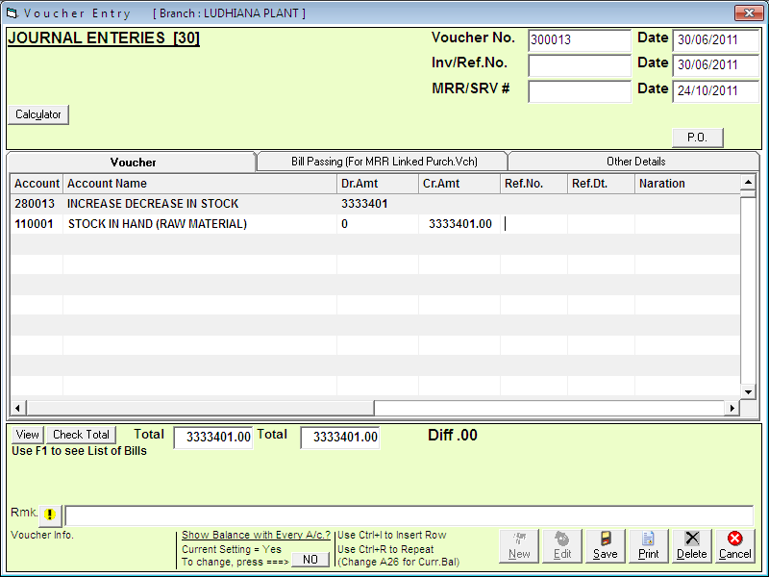

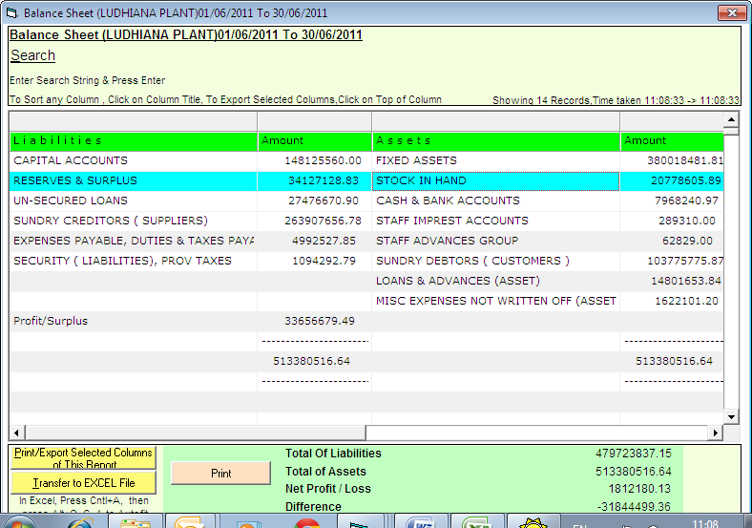

Balance sheet is ready

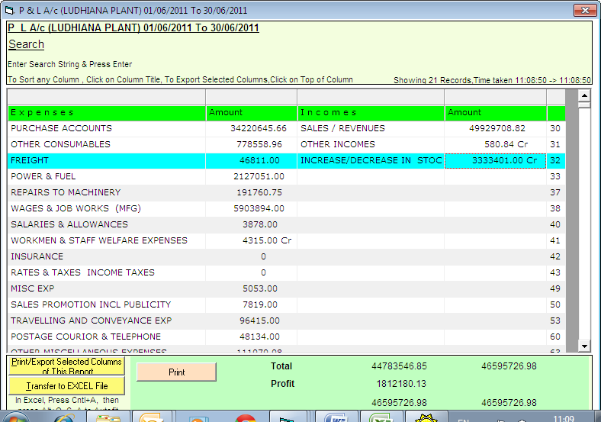

Profit and loss account is also ready
This is a credit ( Cr ) entry

This has the effect of reduction in profit

<< demo over>>

And for info, if we see the P & L Account for the whole of the 3 months
Then

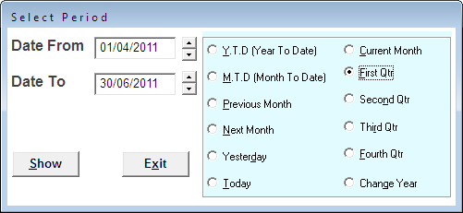

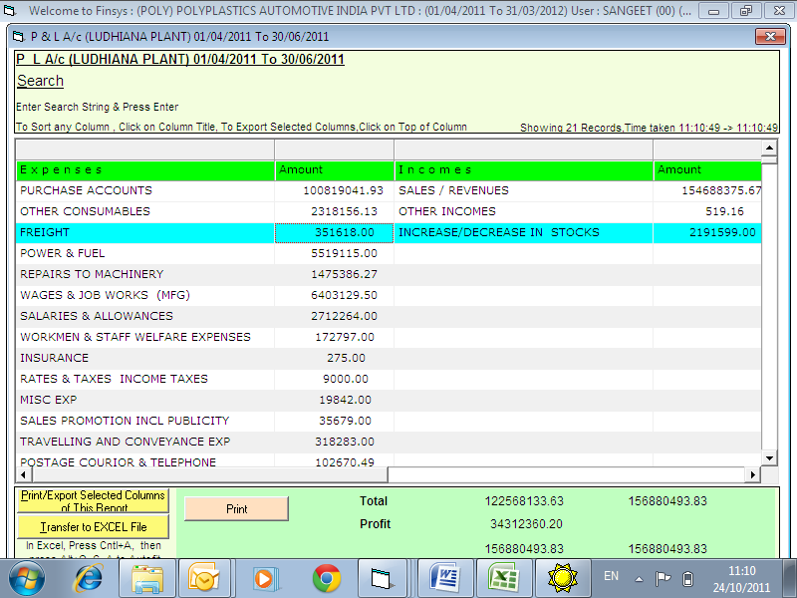

inc dec in stock
April | 4000000
may | 1525000
june | -3333401
Total change | 2191599
Hence ok for both information needs

