Automatic Corrugation Plant – Manual for Finsys ERP
Part 6 : Issue of Material to Production shop Floor
- Part 1 : was getting the Customer’s order
- Part 2 : Making the Job Card for production ,
- Part 3 : Purchase Order and PO Approval
- Part 4 : Gate Entry and Material Receipt (MRR) of paper from vendor
- Part 5 : Quality Approval
and
- Part 7 will be Recording of Stage wise WIP ( Work in process / Machine wise / Stage wise Production )

In this demo, we show you processes of this stage at a standard Automatic corrugation plant’s manufacturing activities. As suggested by Team at Finsys ERP

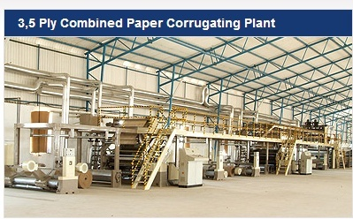

Now, we issue the material

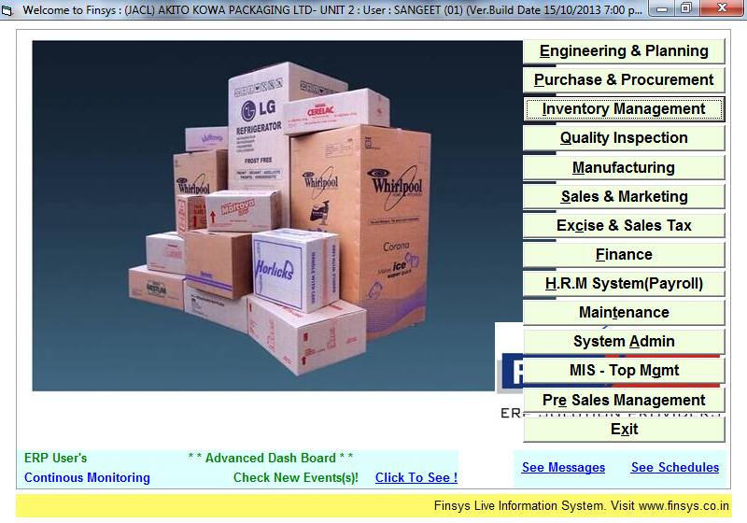

Now we issue the material from stores to the production dept

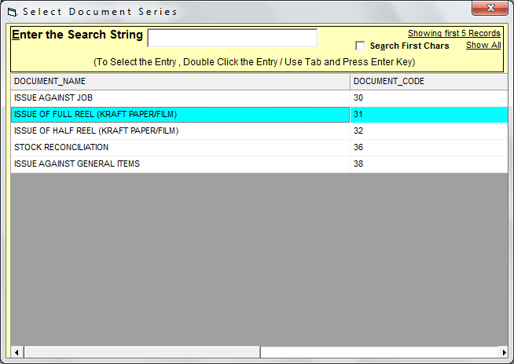
Now , it is a issue of full Reel / half reel as desired.
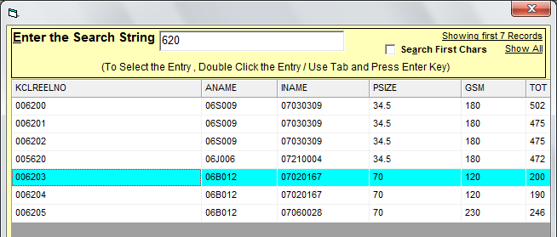

Which reel issued
To which job

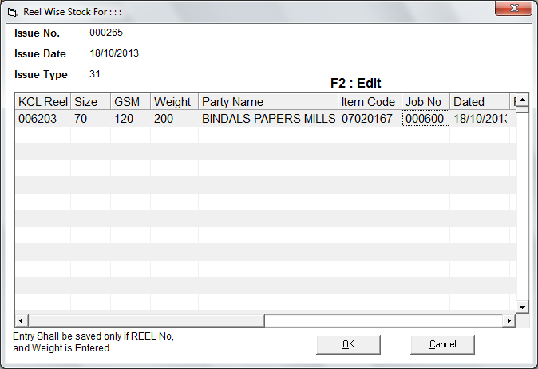

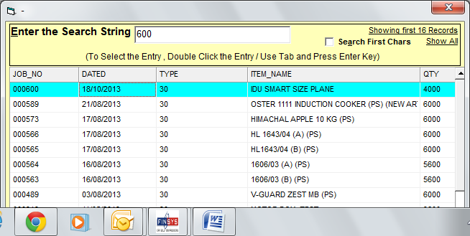

To which job
00600 is this job

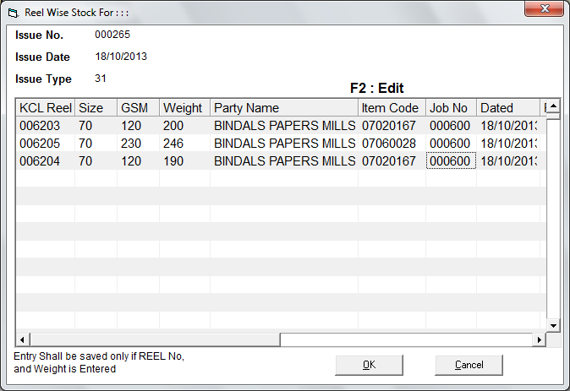

Detailed or Short

Detailed = machine wise work order and plan, and then enter for each stage = First Plan, then execute
Short = work order not required / enter after you get the work sheet for today

Now, we will approve the Job card
And ask production people to work on this Job

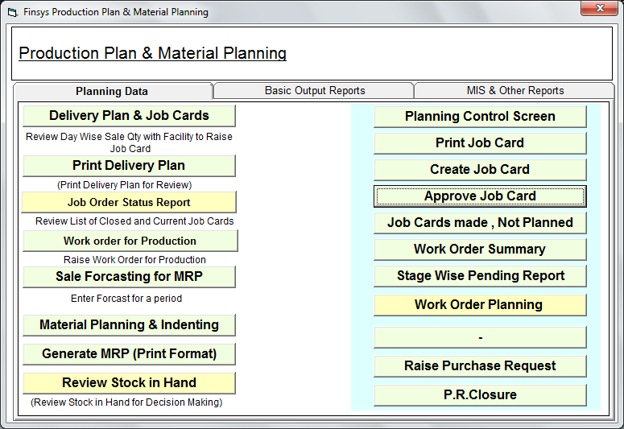

See the next file for the excellent stage wise Work in progress and Production/PPC monitoring

