Automatic Corrugation Plant – Manual for Finsys ERP
Part 5 : Quality Control –
QA Approval of Paper
- Part 1 : was getting the Customer’s order
- Part 2 : Making the Job Card for production ,
- Part 3 : Purchase Order and PO Approval
- Part 4 : Gate Entry and Material Receipt (MRR) of paper from vendor
and
- Part 6 : will be Issue to Production
- Part 7 : Stage wise , machine wise actual production

In this demo, we show you processes of this stage at a standard Automatic corrugation plant’s manufacturing activities. As suggested by Team at Finsys ERP

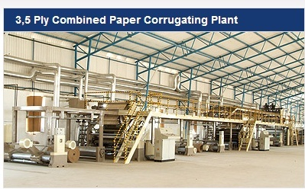

Now over to QC dept
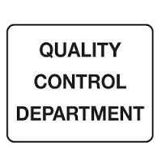
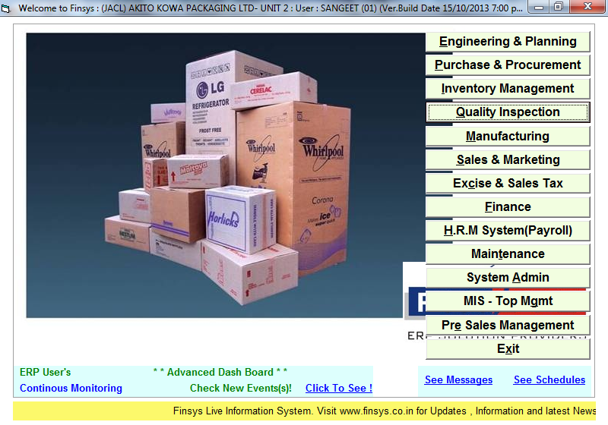

Now there are two ways of QC in Finsys ERP
One is detailed proper way – usually implemented after 2-3 months
Second is simple quick way- usually make applicable in first month itself
(the 2nd method is a short cut for QC and it is available, for companies who do not have staff to fill up all information )

We first have a demo of the Detailed proper method

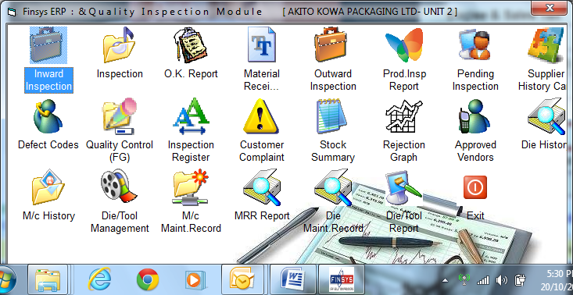

Make the template as under

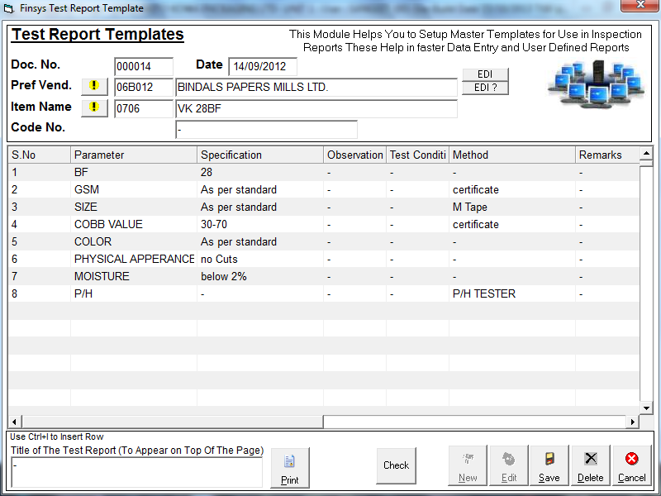

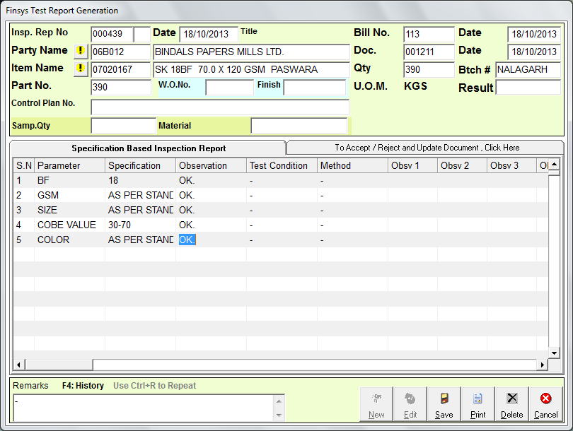
During QC it will give you the standards as it is
And will ask for the observations

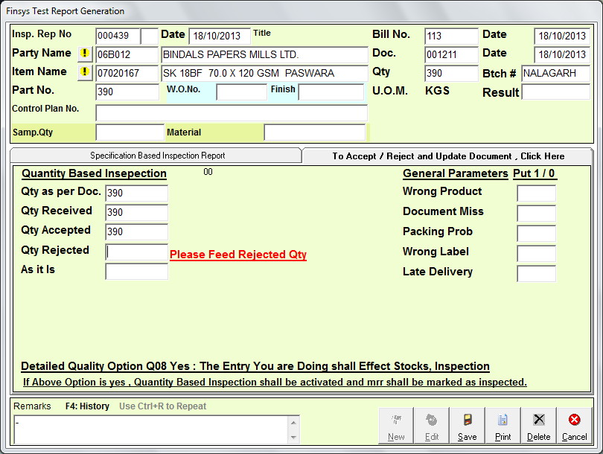
Additional information also (optionally) desired and can be filled up

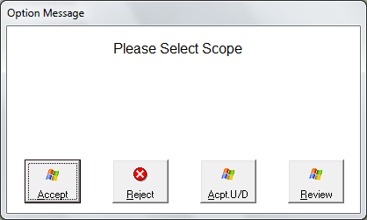

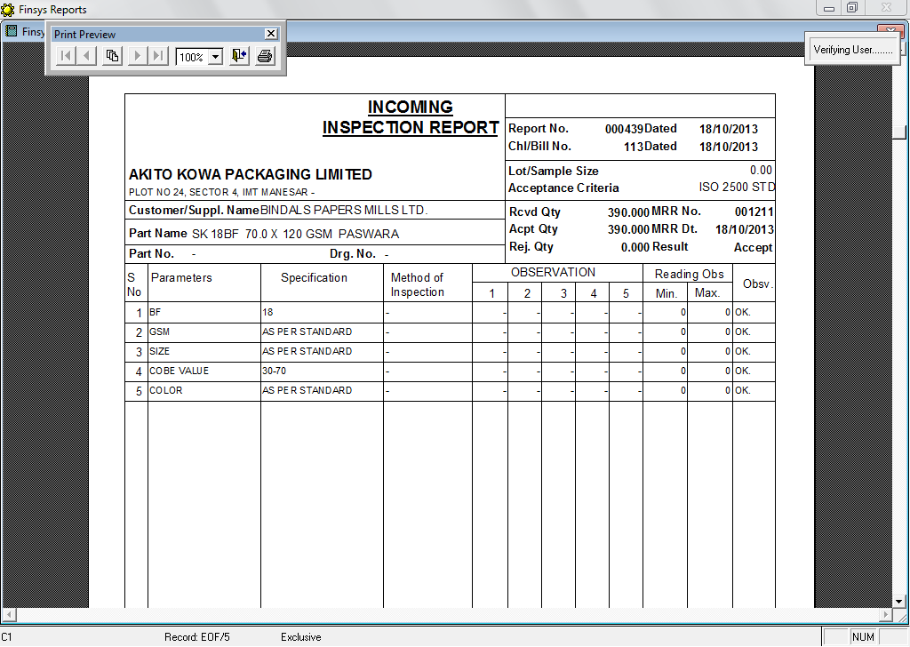

Report is ready
This was detailed method

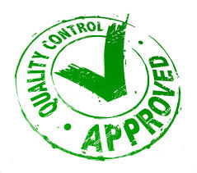

Now, if you want the short cut (fast) QC
Then it is as under

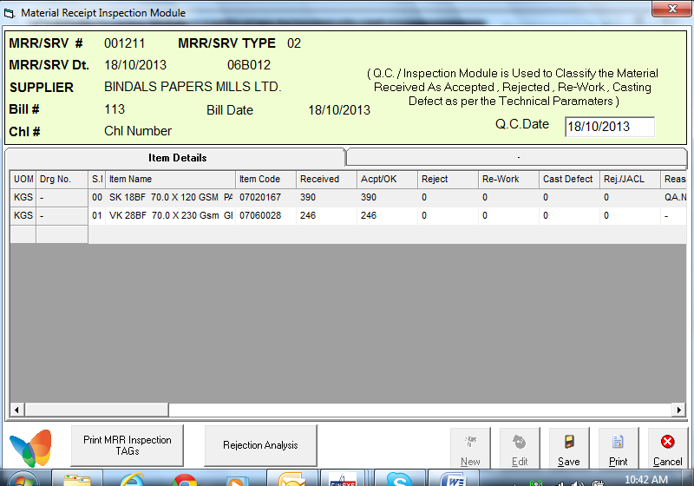

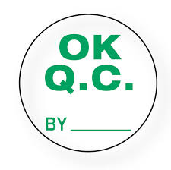

We just did the QA Approval of Paper
- Part 1 : was getting the Customer’s order
- Part 2 : Making the Job Card for production ,
- Part 3 : Purchase Order and PO Approval
- Part 4 : Gate Entry and Material Receipt (MRR) of paper from vendor
- Part 5 : QC
and
- Part 6 will be Issue to Production

Over to next, you must see how it manages the issue of material , specific to a Job.

