Automatic Corrugation Plant – Manual for Finsys ERP

Part 4 : Gate Entry of paper from vendor
and its MRR
- Part 1 : was getting the Customer’s order
- Part 2 : Making the Job Card for production ,
- Part 3 : Purchase Order and PO Approval
and
- Part 5 will be Quality Approval

In this demo, we show you processes of this stage at a standard Automatic corrugation plant’s manufacturing activities. As suggested by Team at Finsys ERP

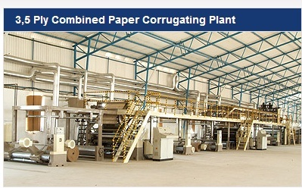

Gate Entry guard / main Materials gate person logs in

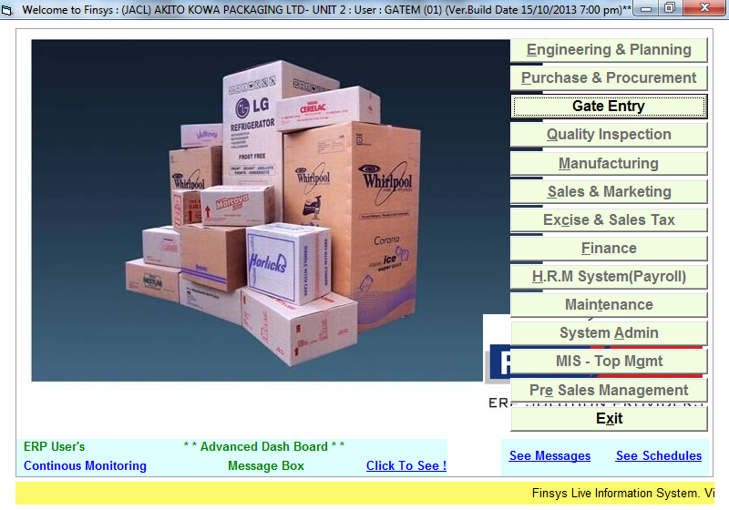

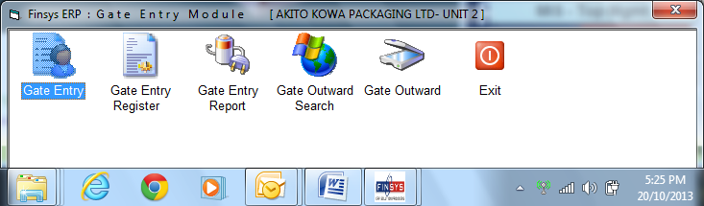

He as the above options for himself and nothing else.
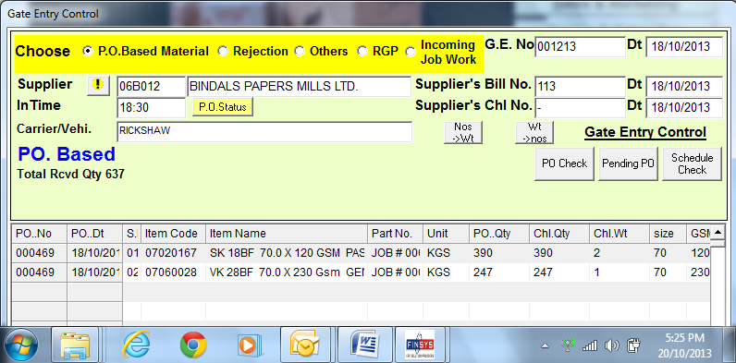

He does the gate entry
Two reels for first item

ERP will not allow excess material beyond the say 10% tolerance allowed for paper.

He can see the LIVE status of pending PO’s
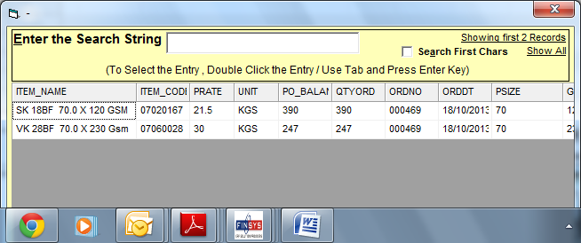

Gate entry

Now is the turn of Inventory stores

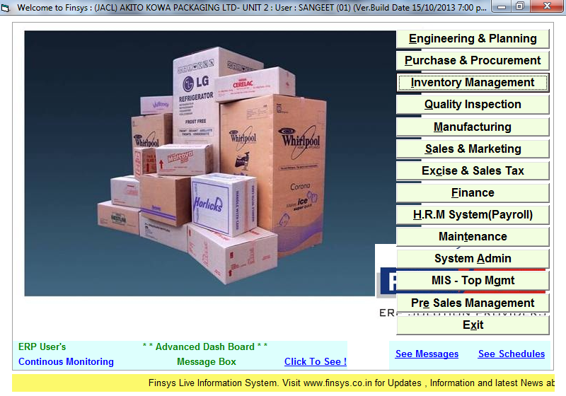

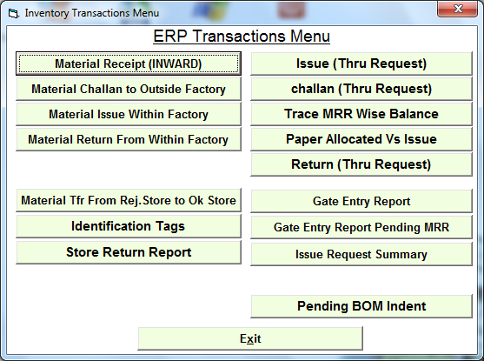

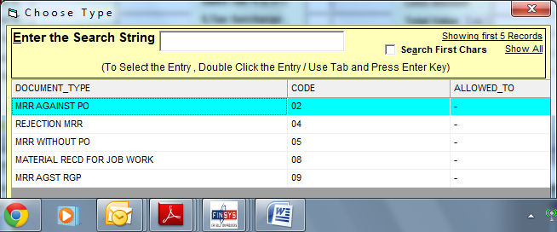

Show the Gate entries still unposted in main stores

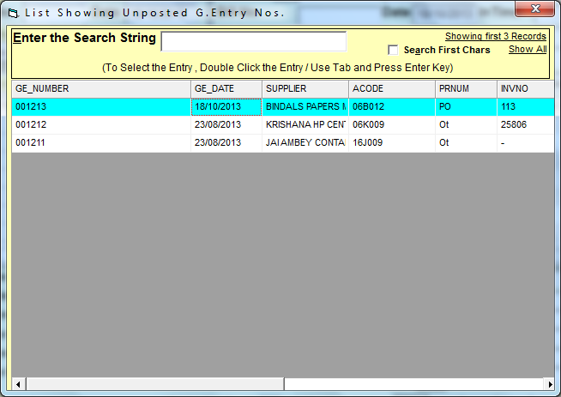

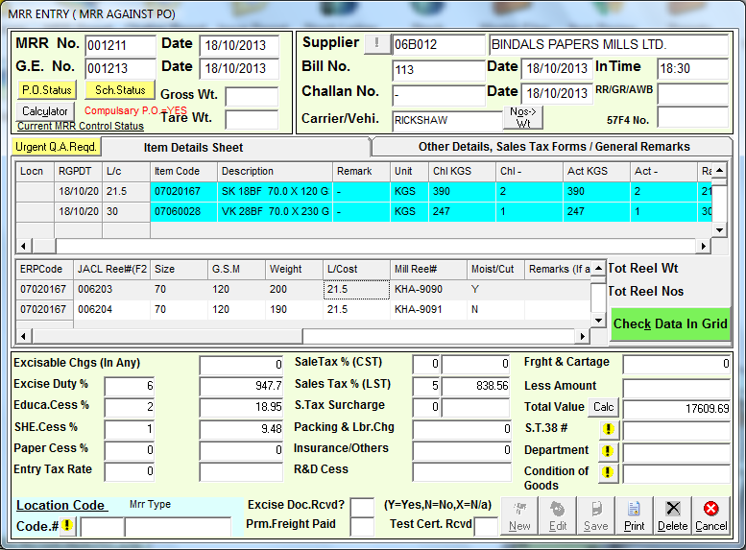
Most of the data is automatic from the gate entry

He has to Fill up the reel wise details
If suppose vendor sends material short
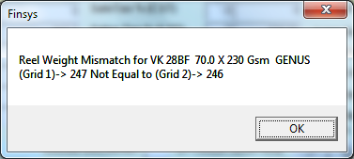
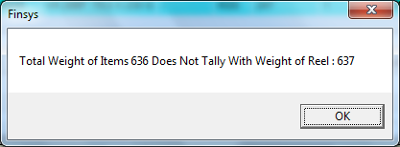
Finally we accept the material with 1 kg shortage ( could be moisture now evaporated )

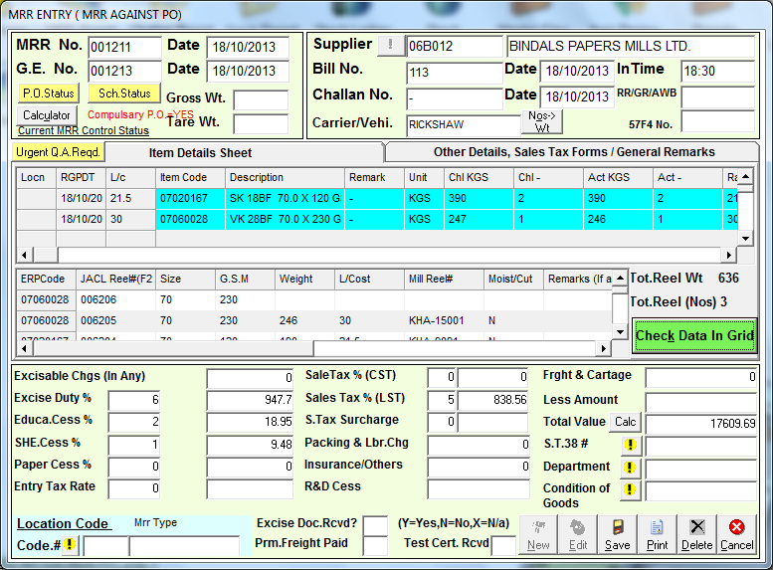
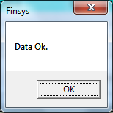
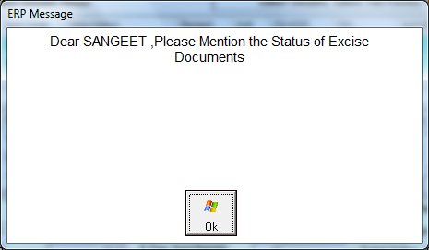
Some alerts, for your safety
Like pink copy received or not ?
And Material test certificate received or not ?

Now the MRR is printed
MRR Material receiving Report
Also known as Good received note, GRN, GIR, SRV, SIR, MRN, MRV, in various companies
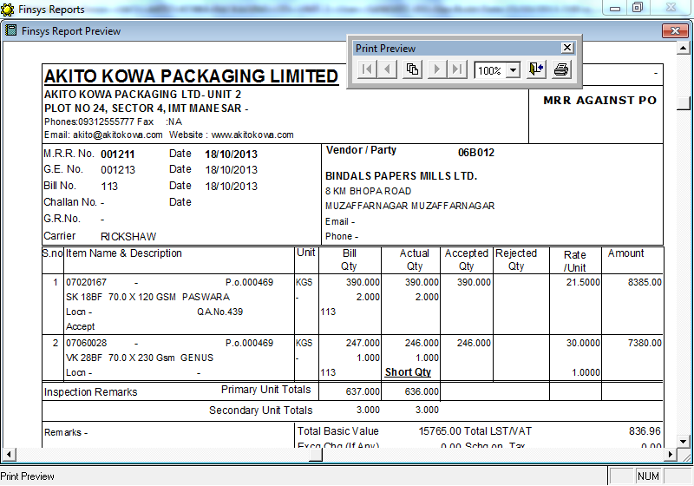

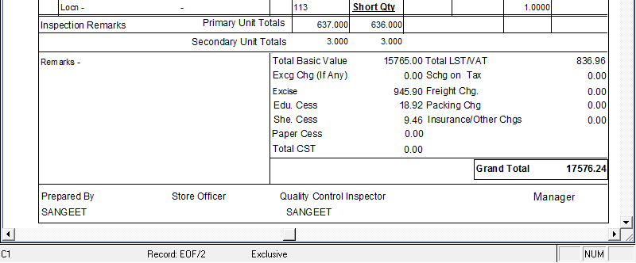

You may also print the reel wise note as under

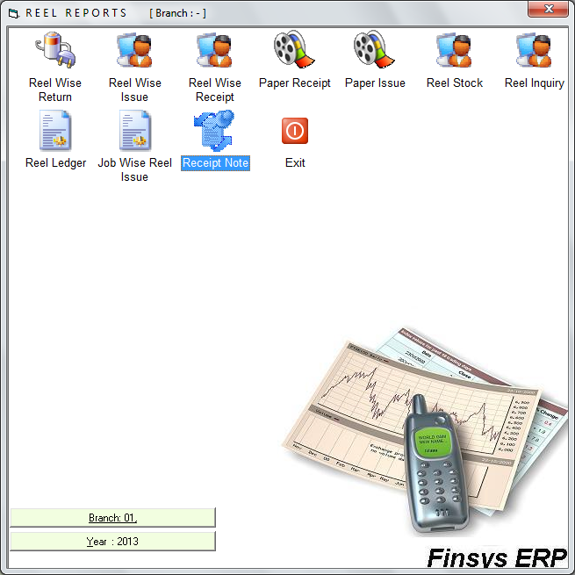

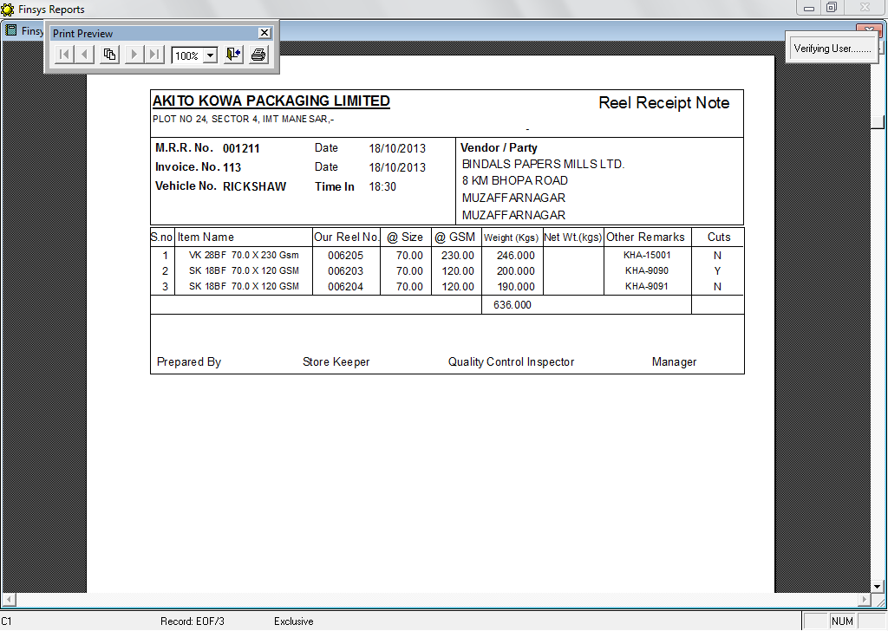

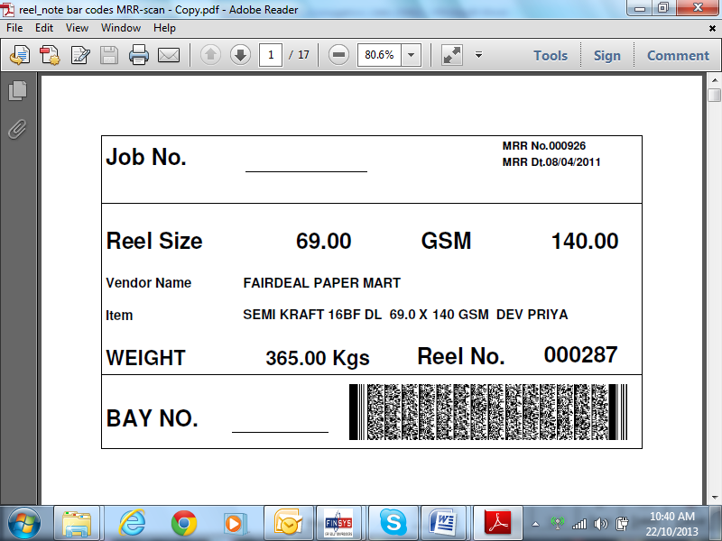

You may also print the Bar Code stickers for each reel (optional, high end option)

We have now done the Gate entry and also the Stores entry
Now over to QC dept.
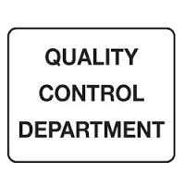
Without the OK from the QC department, the goods cannot be released for production
And if rejected, they go to the rejection stores and are sent out.

If extra control is enabled, if a MRR is QC rejected, then, payments of that vendor can be blocked, till that rejected shipment is sent back to him

Next file please
It will show how the QC dept will do the QC OK
