Automatic Corrugation Plant – Manual for Finsys ERP
Part 2 : Initiation of Process Sheet and Job Card Module
( Part 1 : was getting the order) and
(Part 3 will be purchase of paper for this Order)

In this demo, we show you an Automatic corrugation plant’s manufacturing activities

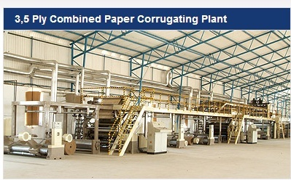

In the previous manual, we saw how the Sales order was received, approved and schedule taken
Now, based on that, , we start the preparation of the Job Card

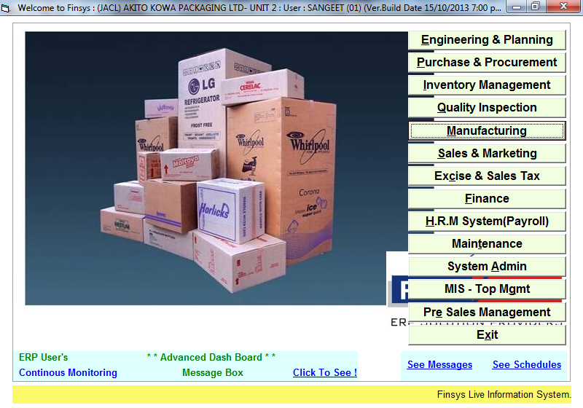

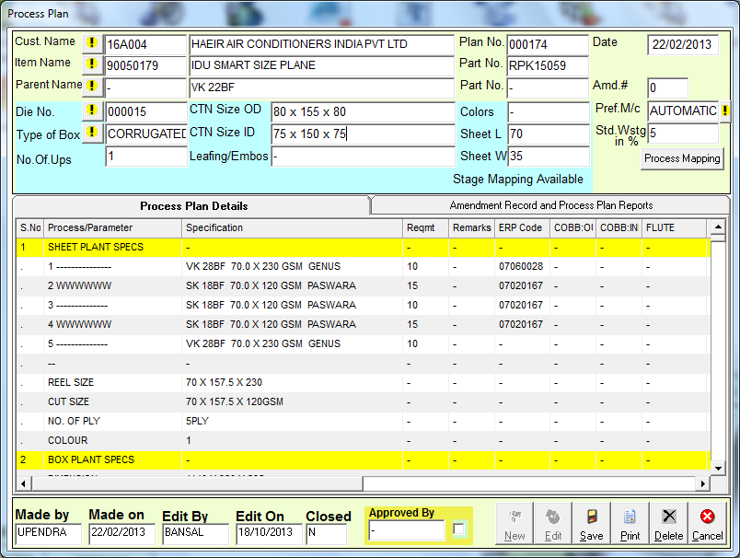

We start making the process Plan

In Corrugation industry, this process plan takes care of the standard technical specifications agreed for this product between the (a) Customer (b) Marketing dept (c) Production dept (d) Costing dept

So, we finalise this one-time document , called Process plan
The future job cards will be made automatically, on basis of this process plan. We will also see which Job cards had deviation , if any.

We select the “Type” of the job card

Each type is different
Select which is your nearest category

For example, the Job card of 3 Ply Carton will be different from a 5 ply carton
We select the box type, that is nearest to our requirement

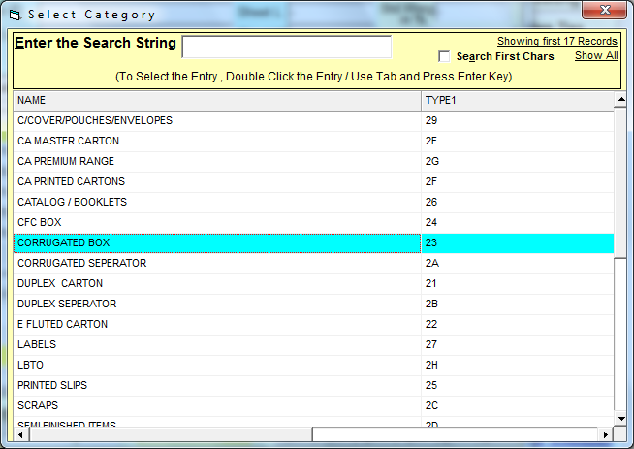

Which Type of box ?

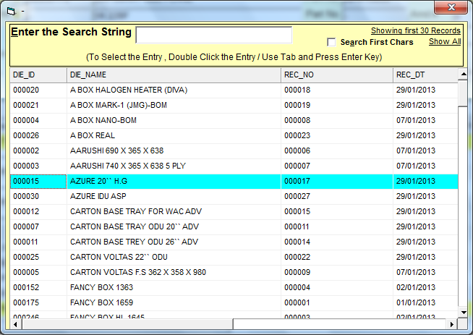

Which die used ?
So that we know the die no and its impressions used

Also it is a clear instruction to the production people.

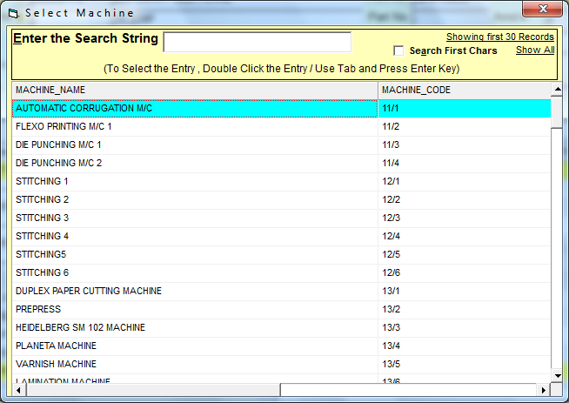

Which preferred machine ?

Standard wastage = 5 %

Requirement is in KG’s per standard Qnty
Here, suppose std qnty lot is 100
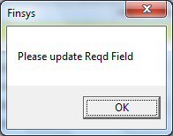

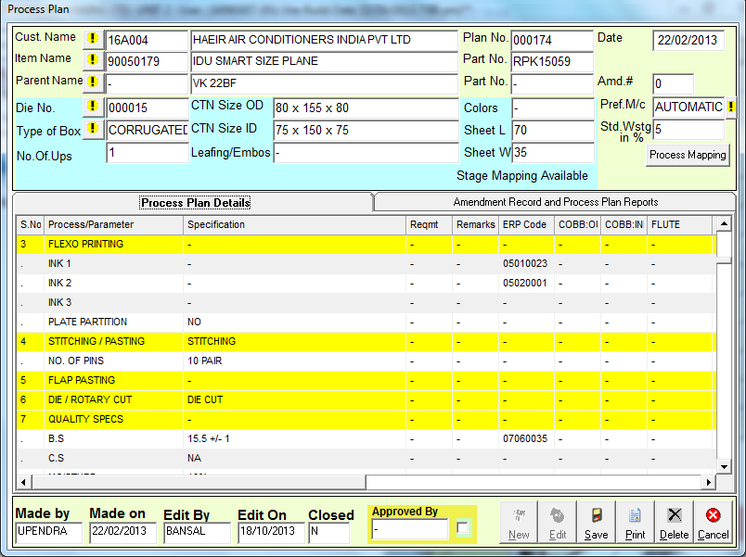

We also have fields for the stitching instructions, die cutting information
And
The Quality specs we have to take care

- BS = Bursting Strength desired
- CS = Compression Strength Desired
- Moisture permitted

Note
See the second tab

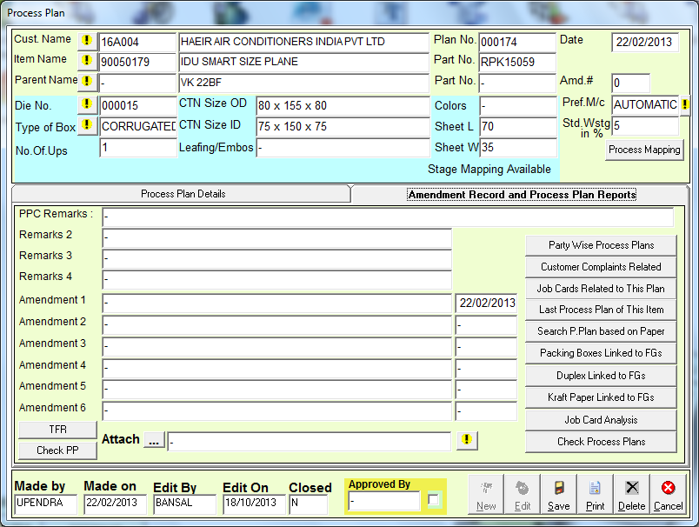

Also we can see the amendment record of this process plan

Also the related MIS reports
- Job cards related to this process Plan
- Duplex related to this process Plan
- Kraft Paper related to this process Plan
- Analysis reports of job cards
- Customer wise Process plans,
- Customer complaints history etc
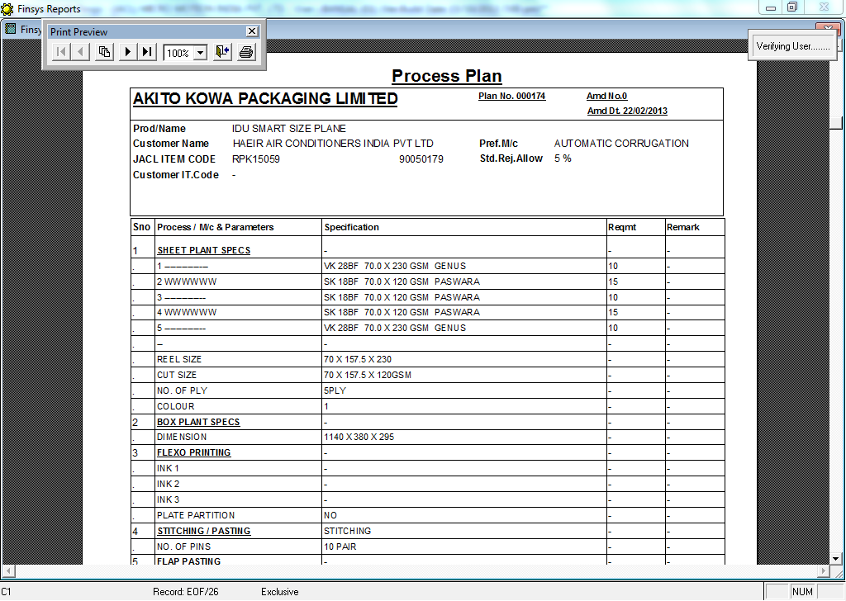

Print out of the Process Sheet, for record and controlled copy file

Now, we make the Job Card for this job,
for this time

go to the Manufacturing Menu
click the PPC Menu

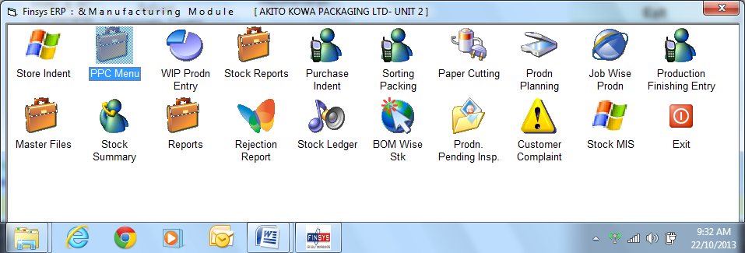

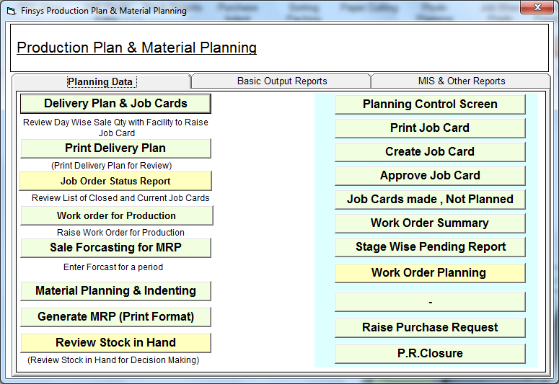

When you press the “Delivery Plan and Job card” button
It automatically, shows the Day wise pending Delivery Schedules

And gives you a handle to click and create job card automatically.

The First Screen = See pending Sales Schedules

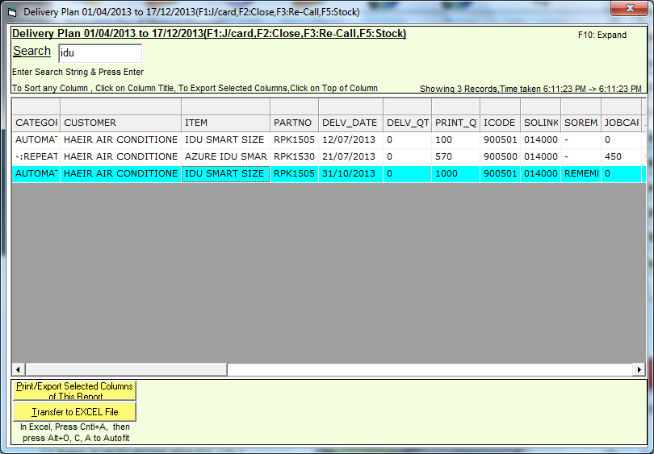

We click the last row ( our 1000 nos )
And the Job card screen is automatically populated from the “one time” process sheet.

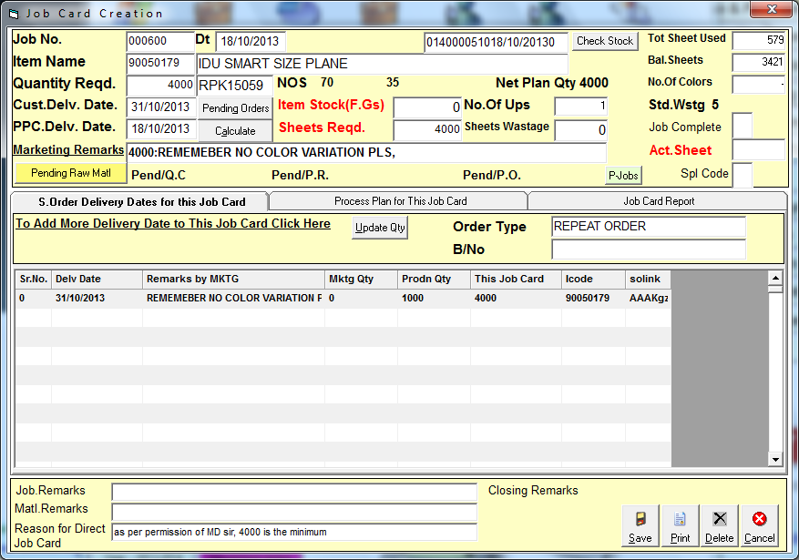

Here you go to first tab
And tell the ERP, how much you want to make.

Here you have a automatic plant
And you somehow has excess capacity and want to make 4000 nos
( remember, SO qnty was 8000 boxes, but schedule was only 1000 boxes)

Since my minimum lot was 4000 nos.
And I took permission of the MD for this
Make a note of this and create job card for 4000 boxes

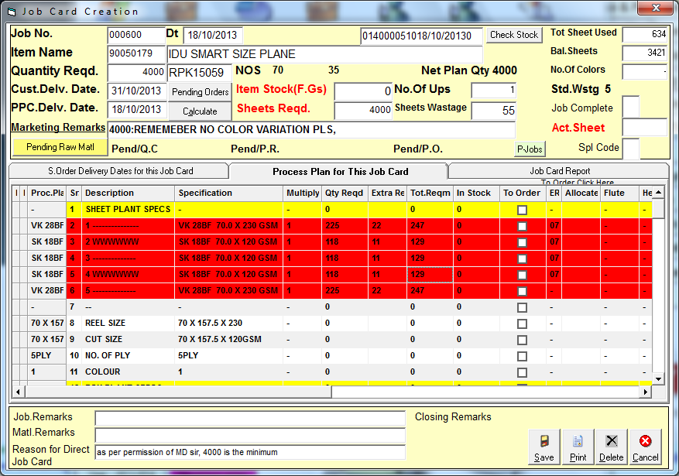

Second tab calculations of paper etc is Ready

Calculations are automatic
See that 22+11+11+11+22 = 55 extra kg allowed

But it is in RED
Since that specific paper is not in stock

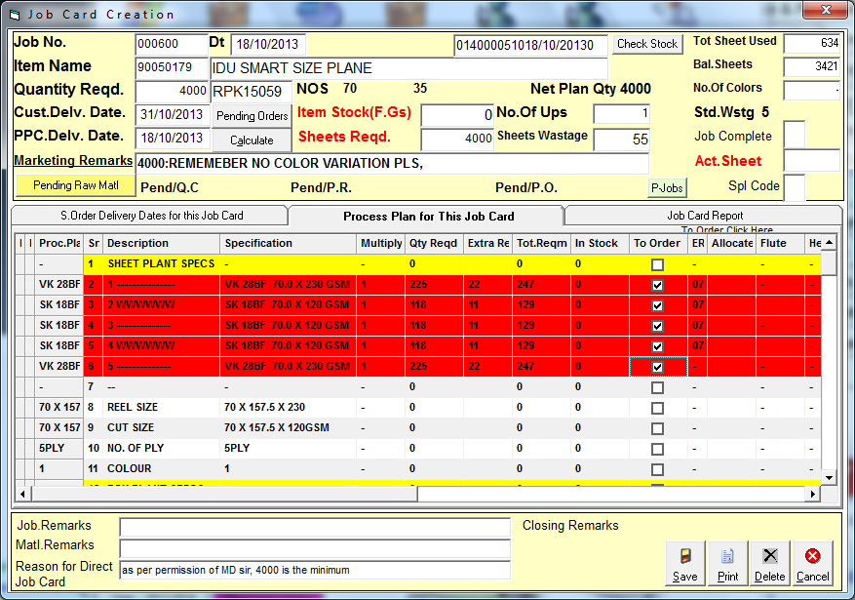

Click the boxes, to Make purchase indent

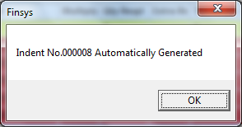

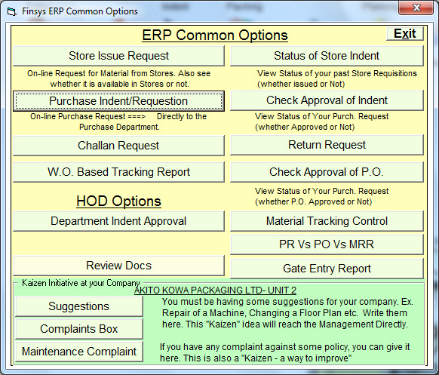

It went automatically to the Purchase dept
And Purchase dept can see it / PPC can print it via the above option
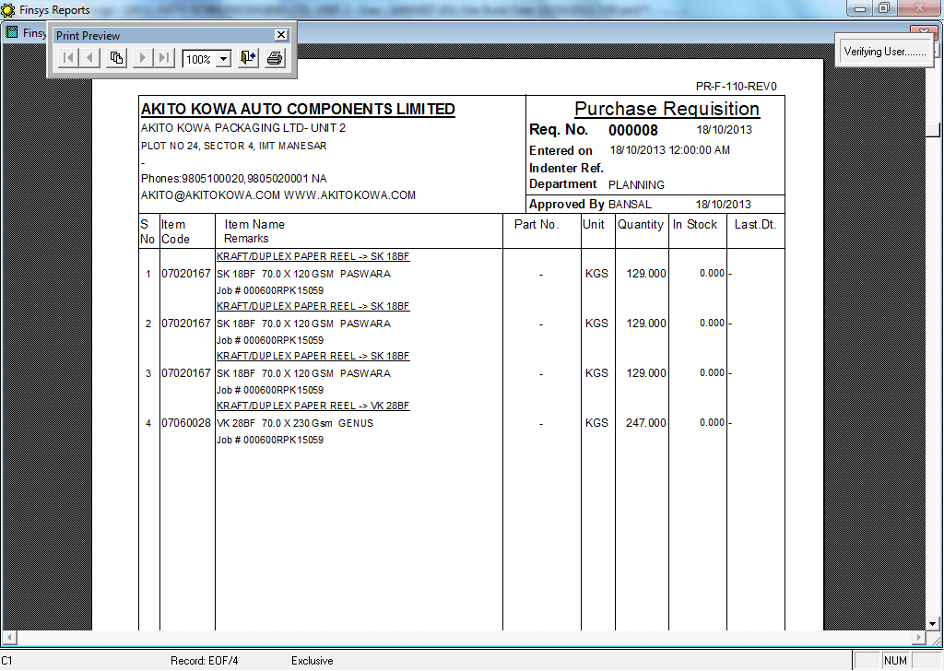

Indent made
With info of stock in hand

And also reference of the required job card number

So, this was Part 2 : Initiation of Process Sheet and Job Card Module
( Part 1 : was getting the order) and
(Part 3 will be purchase of paper for this Order)
Over to next file

