07 PPM and cost of rejections

Name plate on the front of a Japanese JV
“We are a 100-PPM company”

How to measure
For every production entry,
Enter not merely, “passed”
But both made and rejected, passed is the net.

Item Wise Rejection upto 20 Reasons and Loss of Revenue due to This.
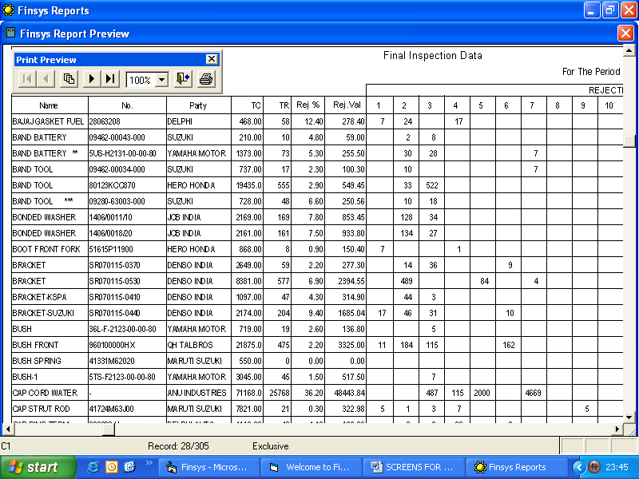
Totals and PPM !!! automatic , online , all the time

COPQ
Cost of Poor Quality

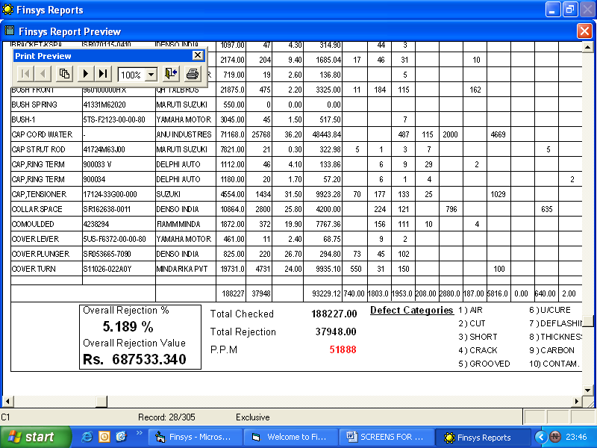
Chart Showing 20 Columns of Rejection Analysis
Control Your Rejections with 20 Objective Data !!!!!!!
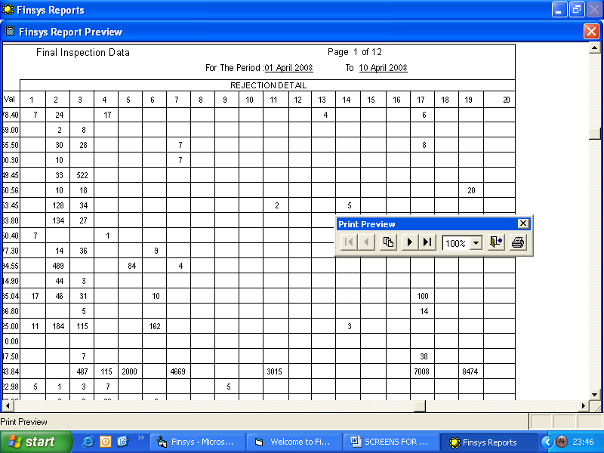

Over All Rejection Report
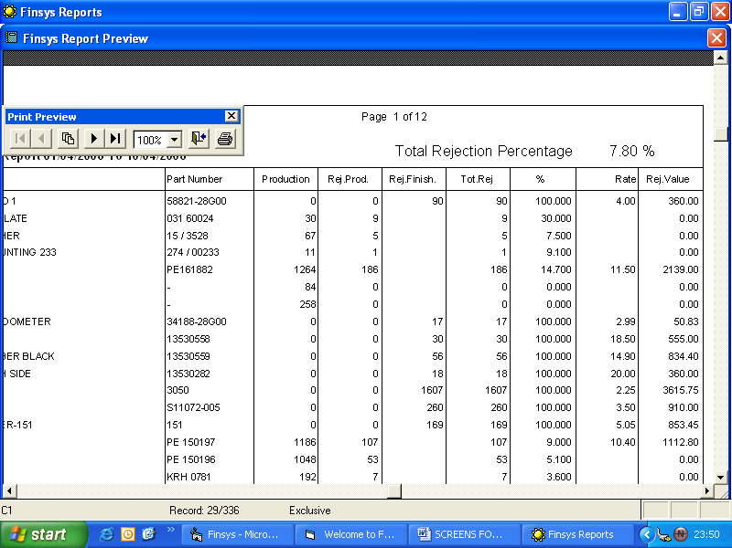

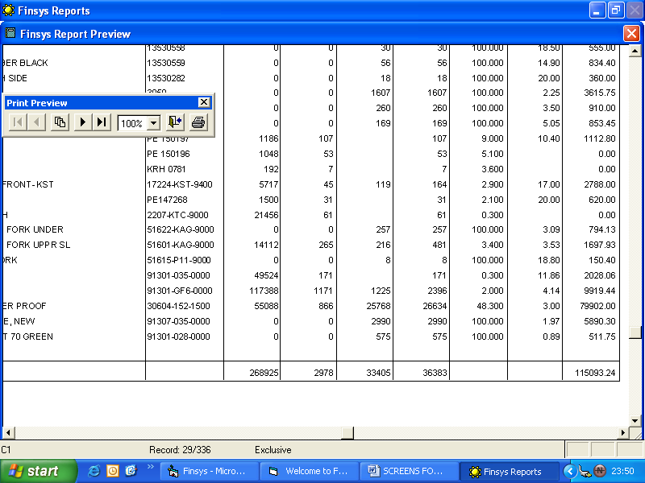

1-10-100 rule
same problem may cost just Rs. 1 to curb there
same problem may cost just Rs. 10 to at next stage
same problem may cost just Rs. 100 to curb if it reaches customer

Control Your Rejection , Waste of your Money , due to fault of prodn …!!!!!!!!!!!

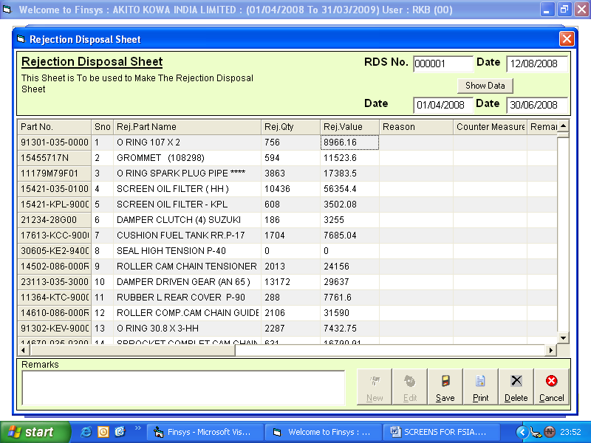

Make them accountable for any rejection done !!!!!!!!
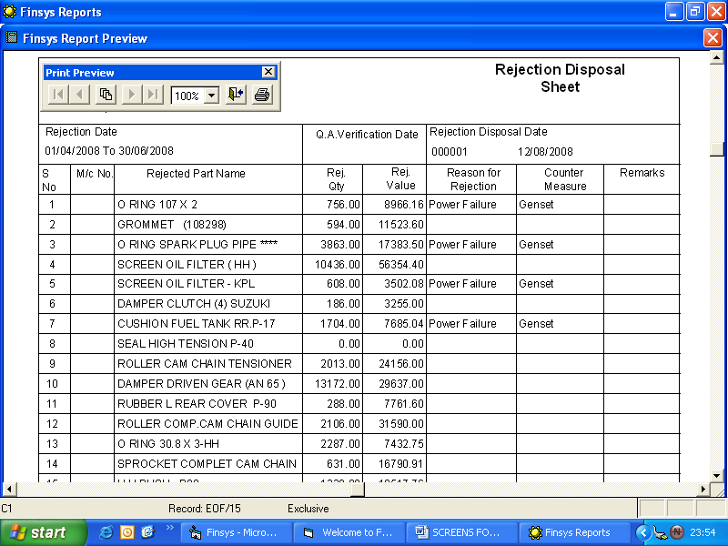

“Japanese”
“Mistake Proofing”

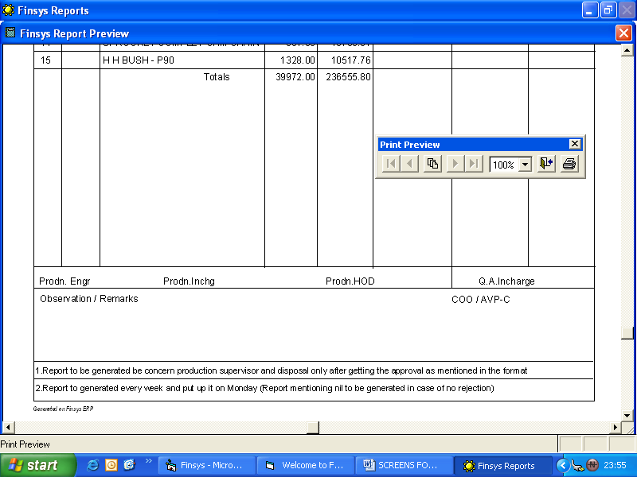
Why Did This happen , what is action plan for Next Month ……..
Production and PPM Analysis.

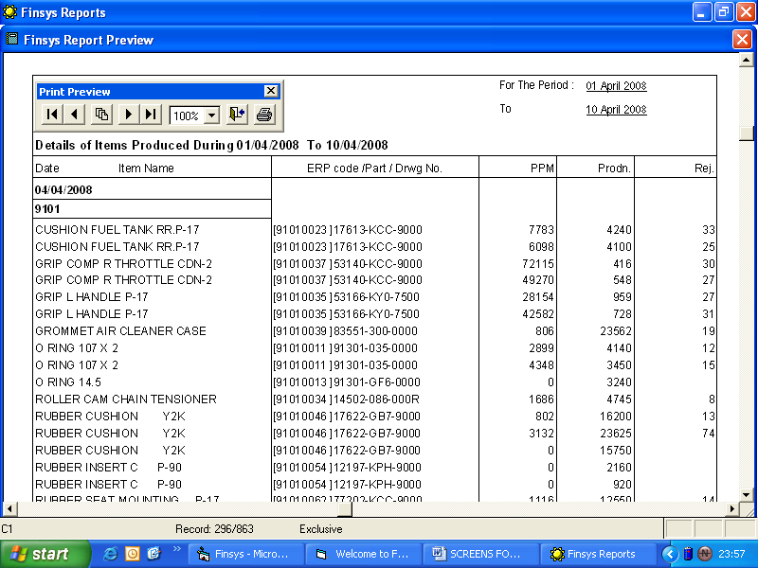

Rejection Value with % Rejection


