Costing while making the job card (day to day activity)
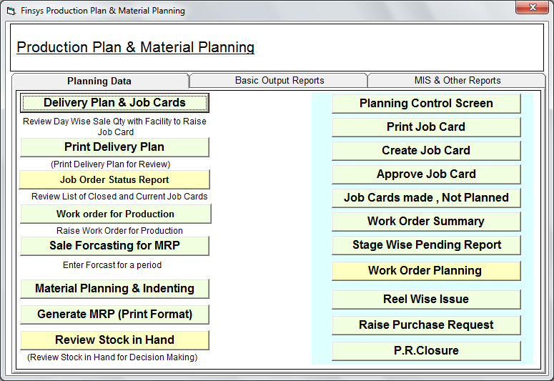

Now there is a sales order, with a delivery schedule for next week, for which we make a job card

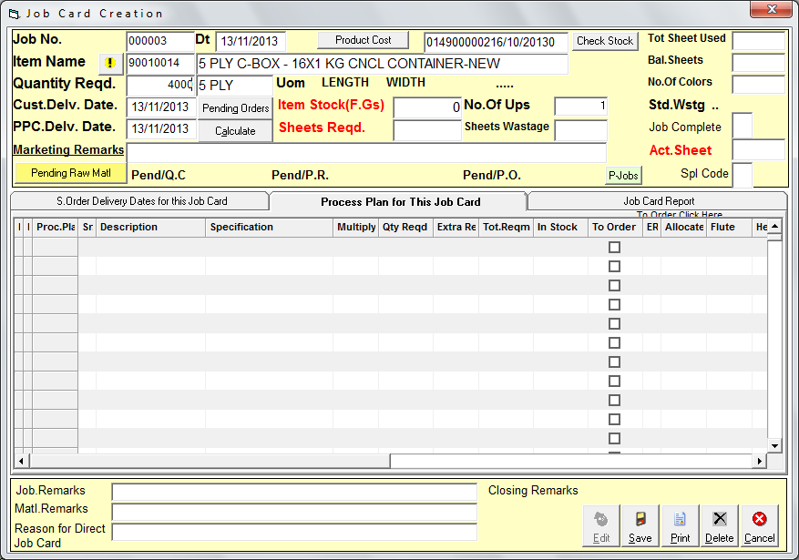

I select the item and suppose fill the qnty of job card as 4000 nos

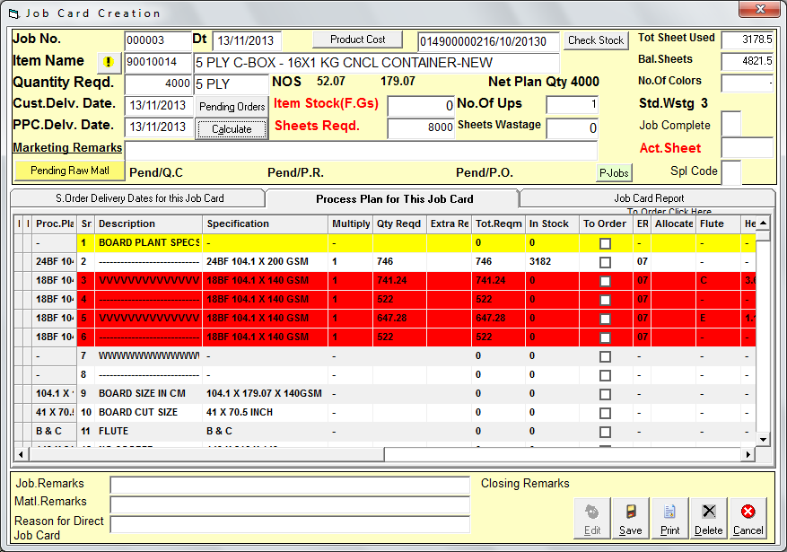

Immediately the ERP says, it will need these 5 paper sheets
Of which first is available and is in WHITE

And other 4 layers are short supply
Hence in RED

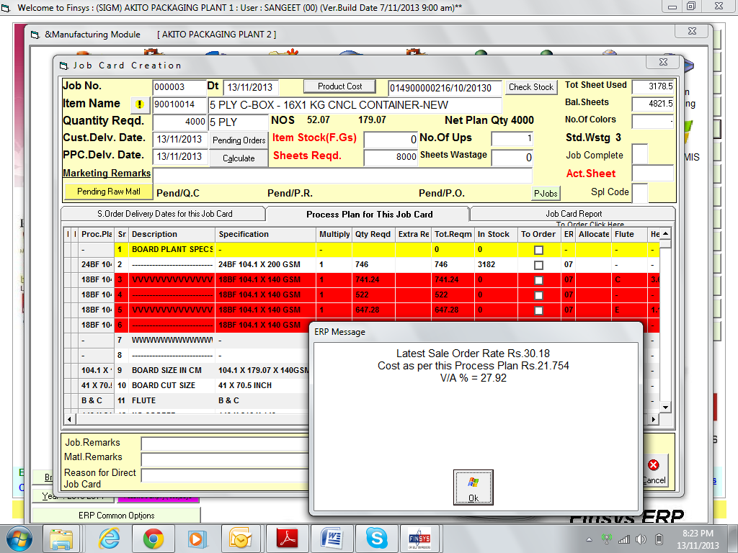

At this stage, the paper selected is ideal fit and gives me paper cost of 21.754 and Value addition of 27.92%

Now, I either wait for new paper of exact specs
Or select a alternate paper

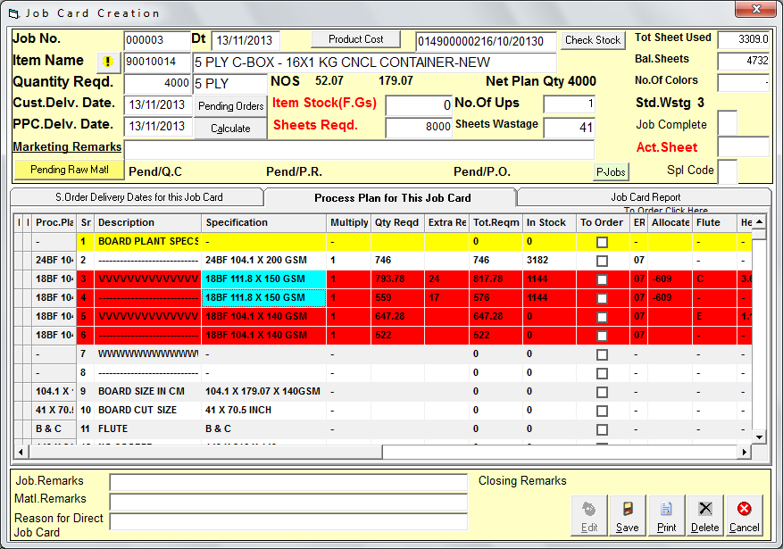

I do this change for two layers

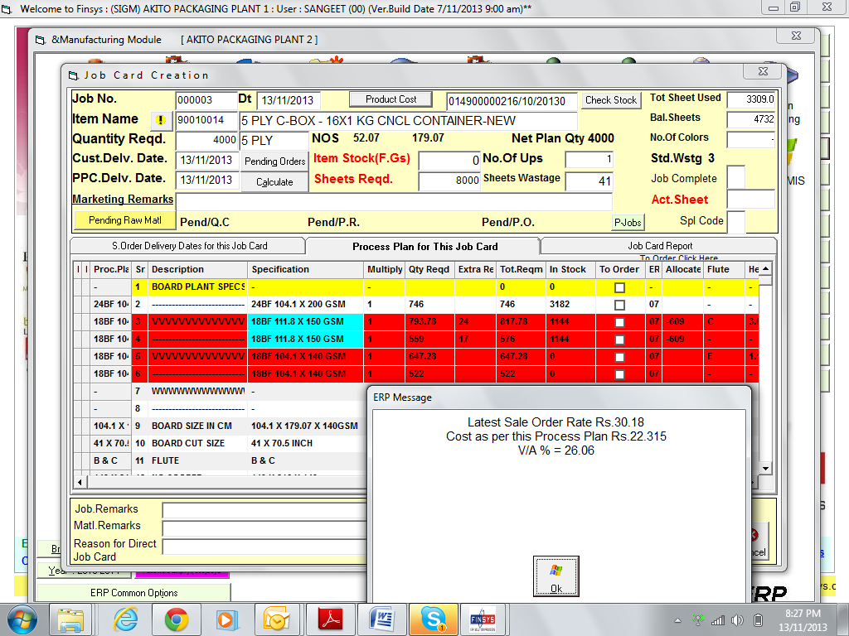

Check cost
The VA comes down to 26 %

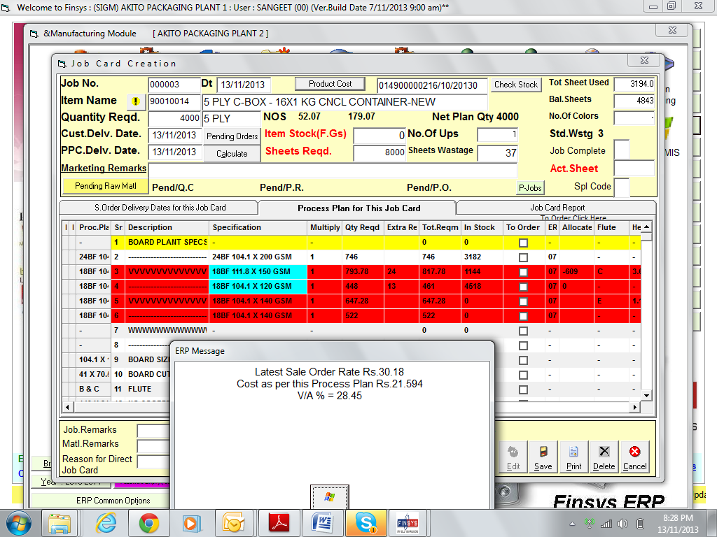

I make another change
2nd layer, increase to 150 GSM
And 3rd layer , decrease to 120 GSM
Now VA is 28.45%

And paper is available

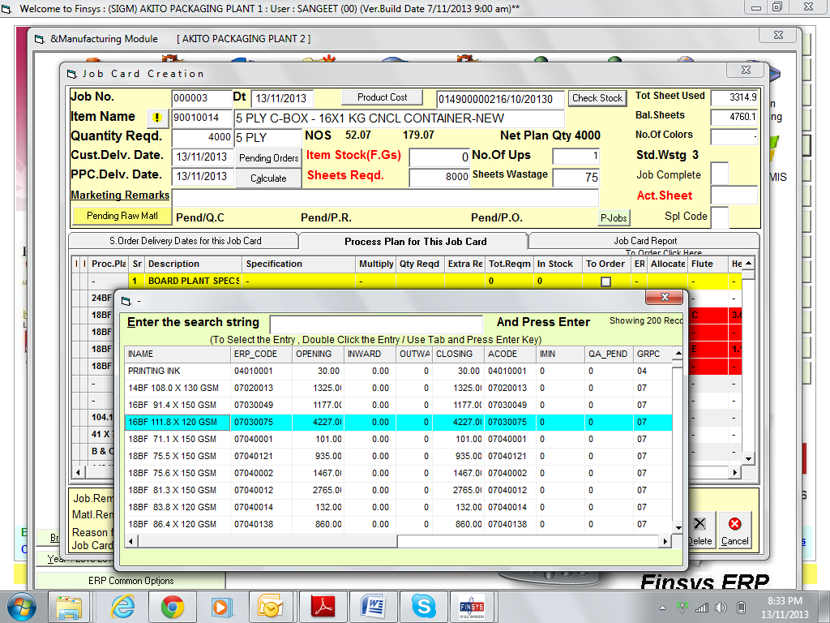

Press the “check stock”
To see similar items with stock

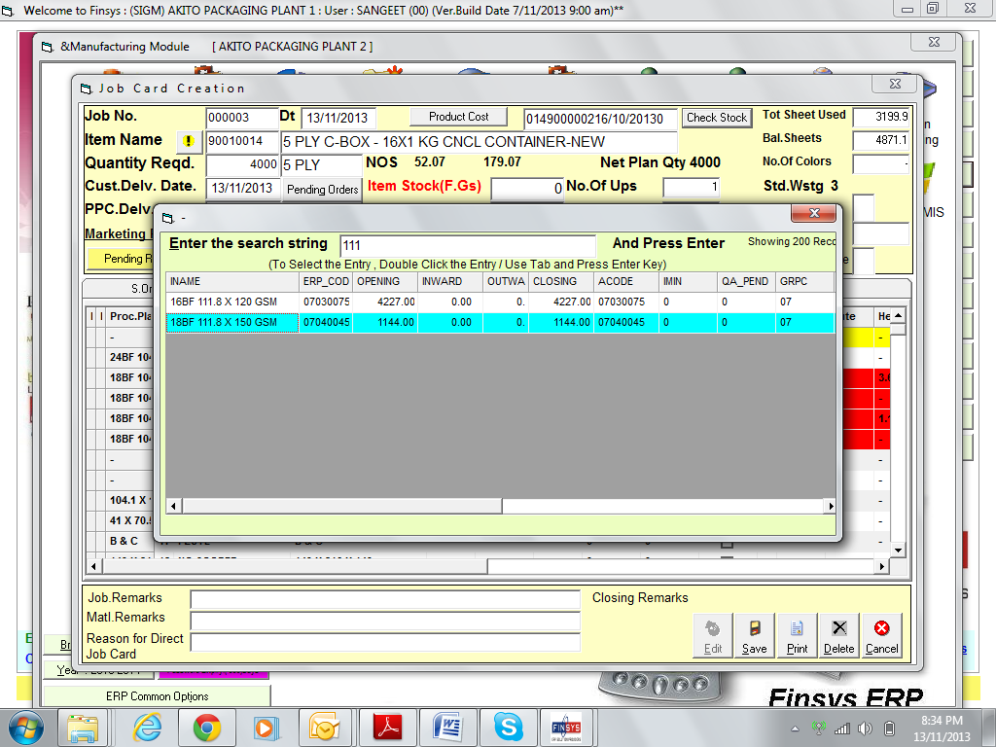

I can further search the size

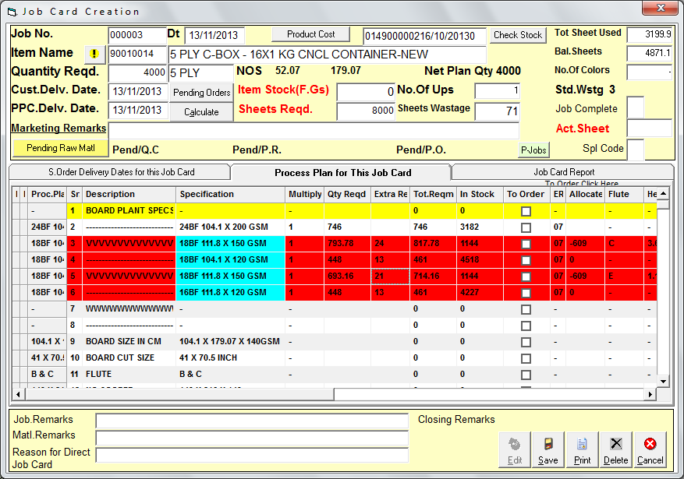

Now all the 5 paper are available

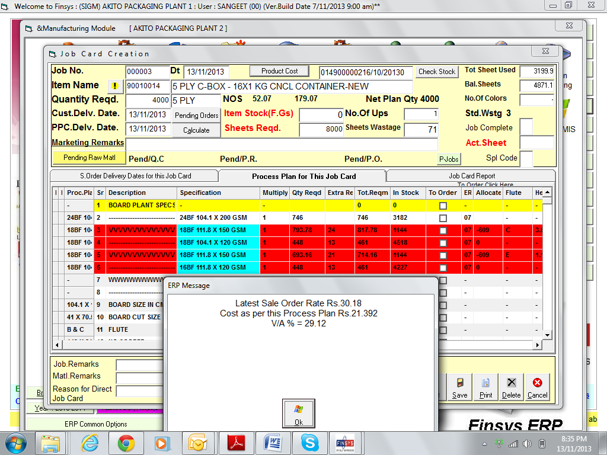

And the revised cost is now only 21.392
And the Value addition is 29.12%
Better profit than what we wanted

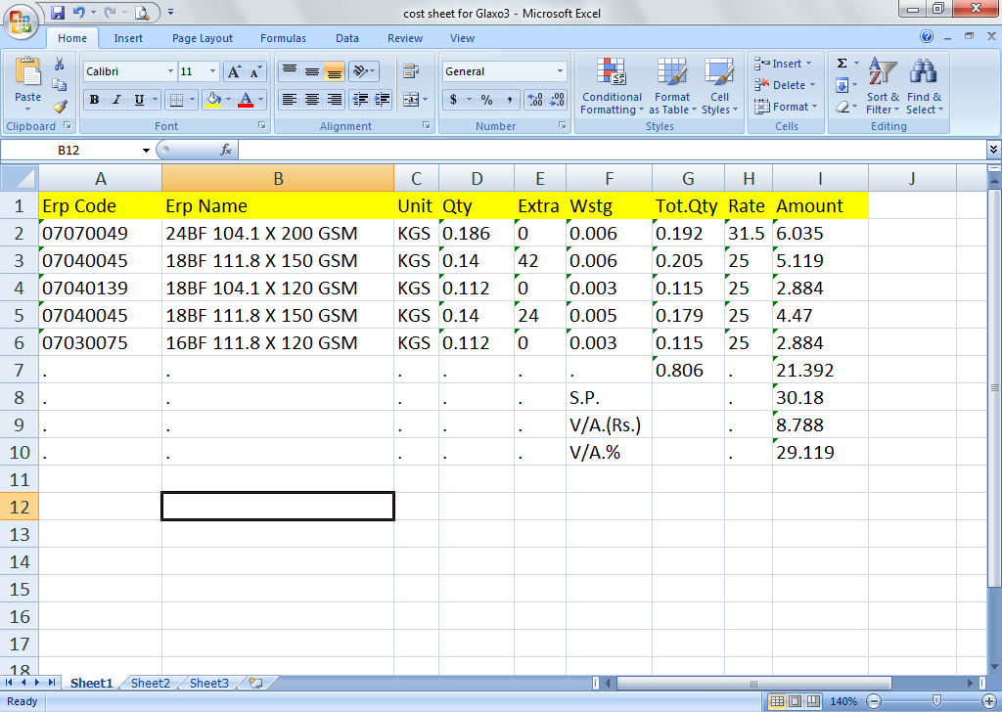

Humbly submitted please

