Automatic Corrugation Plant – Manual for Finsys ERP
Part 7 will be Recording of Stage wise WIP
( Work in process / Machine wise / Stage wise Production )
- Part 1 : was getting the Customer’s order
- Part 2 : Making the Job Card for production ,
- Part 3 : Purchase Order and PO Approval
- Part 4 : Gate Entry and Material Receipt (MRR) of paper from vendor
- Part 5 : Quality Approval
- Part 6 : Issue of Material to Production shop Floor
and
- Part 8 will be Invoicing

In this demo, we show you processes of this stage at a standard Automatic corrugation plant’s manufacturing activities. As suggested by Team at Finsys ERP

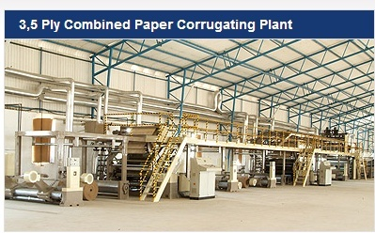

We had made a job card in Part 2 of the demo
Now we approve it and ask people to start working

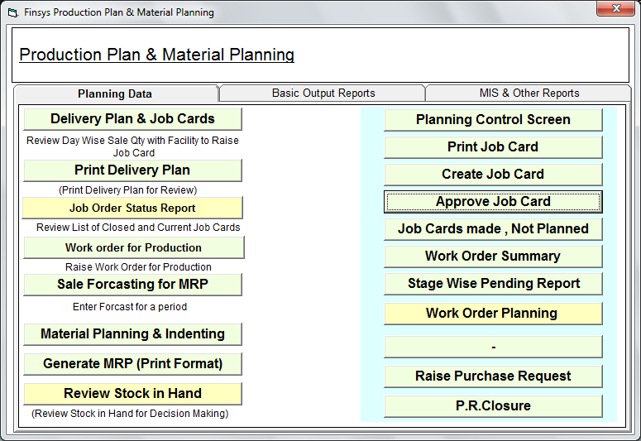

The job card is issued
Seen, checked
And then approved online

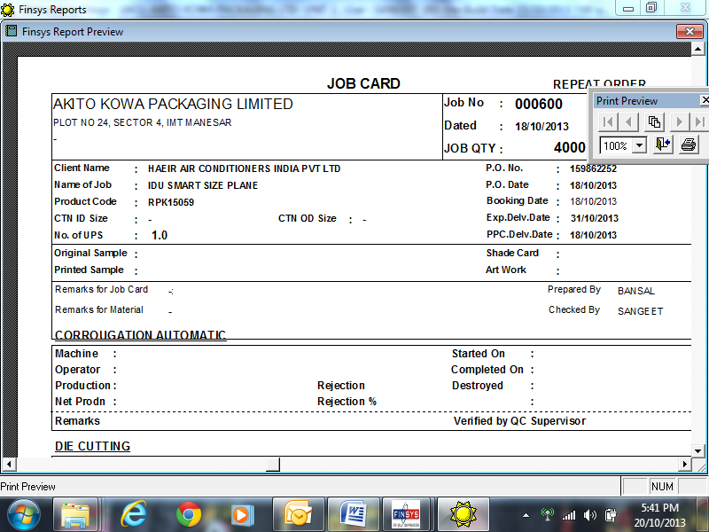

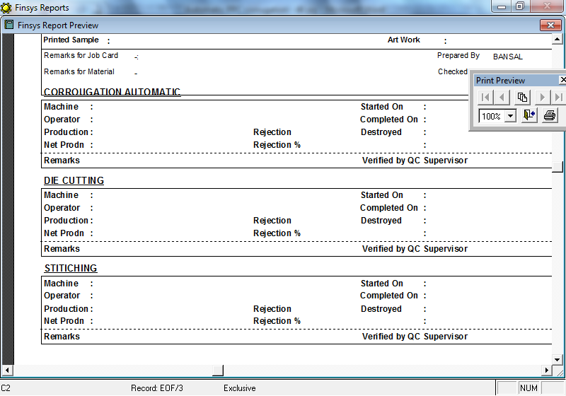

Job card is ready

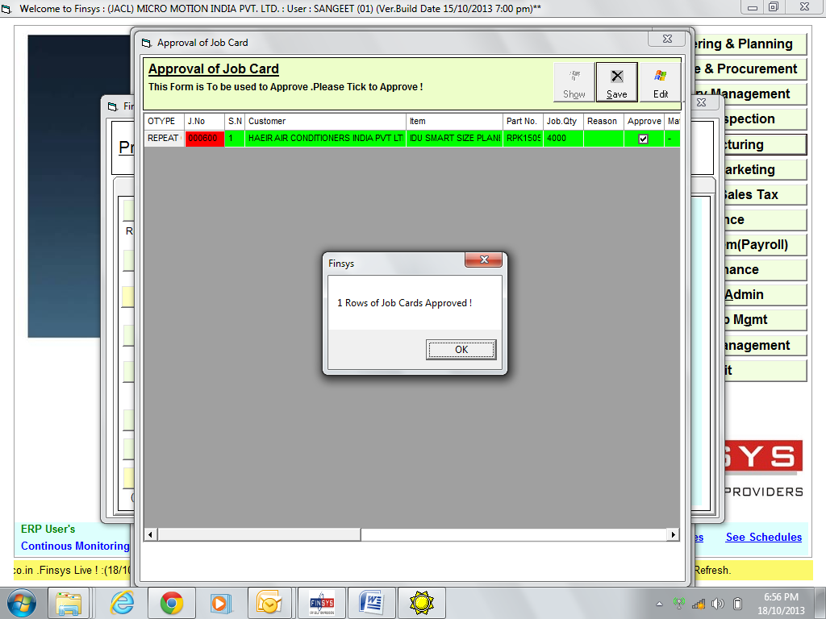

And so on
Thereafter job card WIP production entry done and goods brought to the Finished goods store for shipment to the final customer

Let us see the dashboard
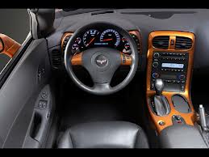
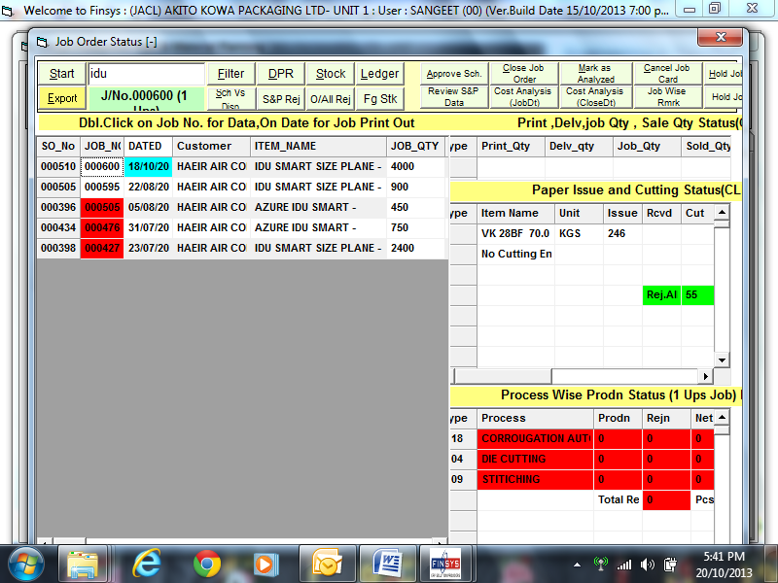

It is in RED, since it is pending to be done by the production people

Which stages it has to go ??
ERP shows you
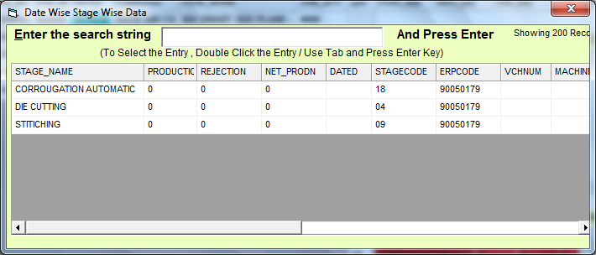
Entry yet to be done

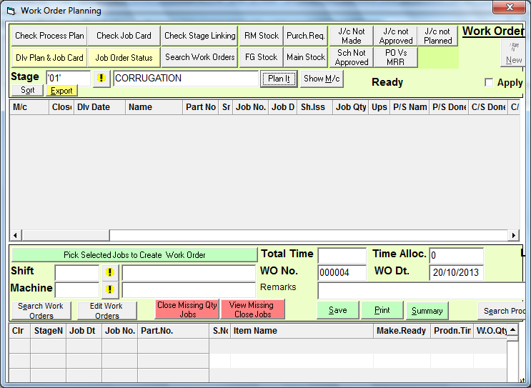

In this screen, the shift wise / machine wise / job wise work allocation is made

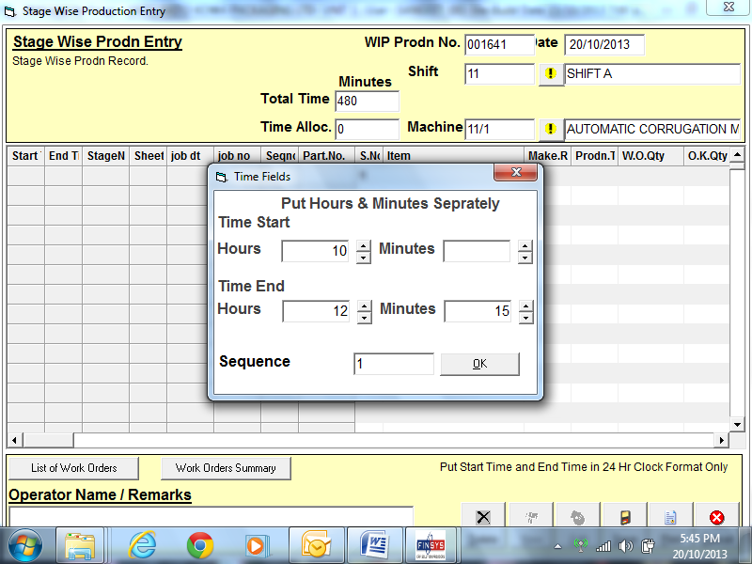

Production entry being done
With time

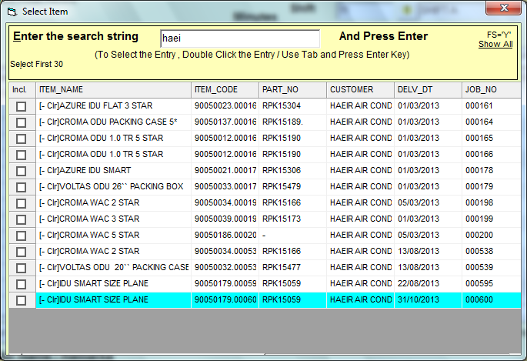
Which job
I select my 00600 no job card at bottom

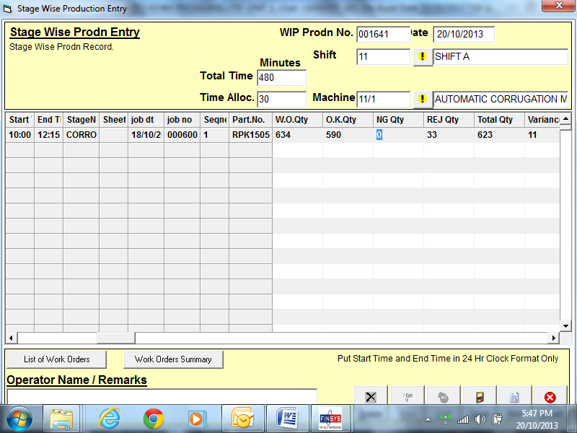

Entry in progress
Showing

OK qnty
Not good qnty
Reject Qnty
And variances

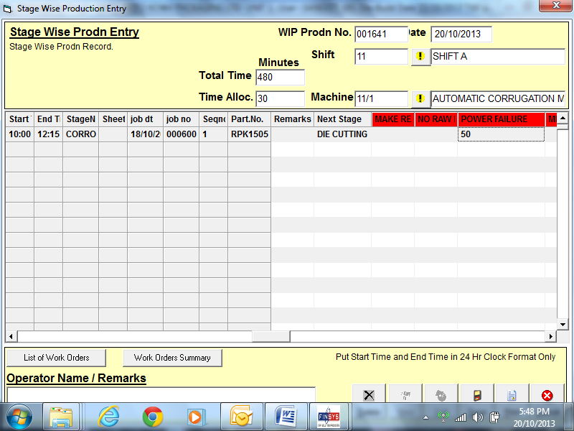

Also reason for downtime

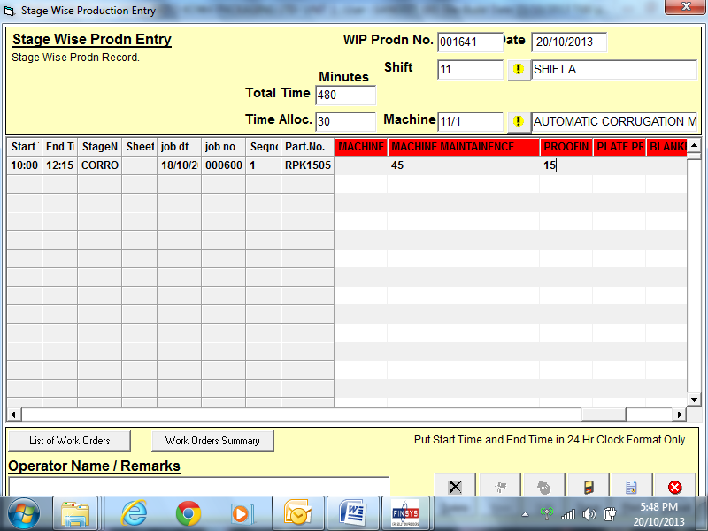

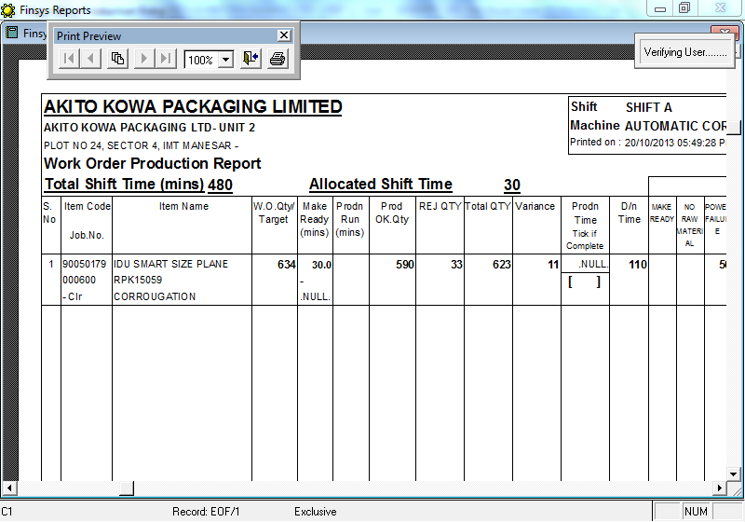
Job card is printed
Either unfilled, and later filled up by users by a ordinary pen
( and later feed into computer )

Or directly in computer system

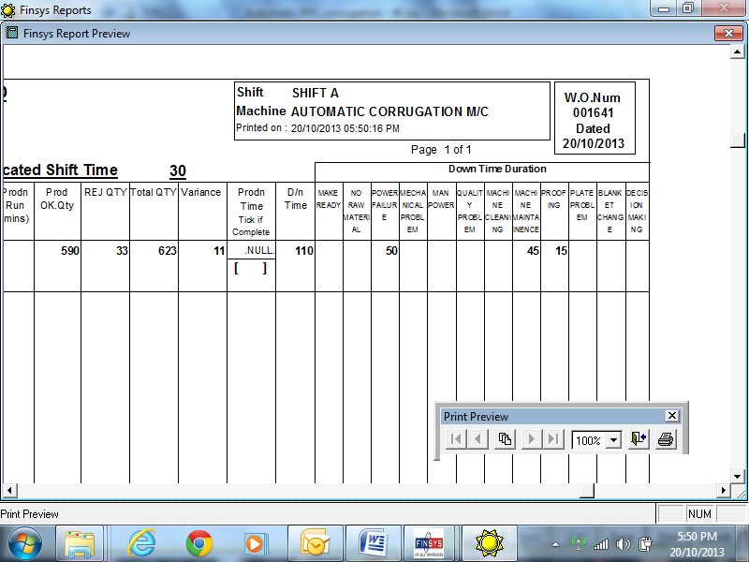

Right side of machine loading card
Showing the down time reasons too

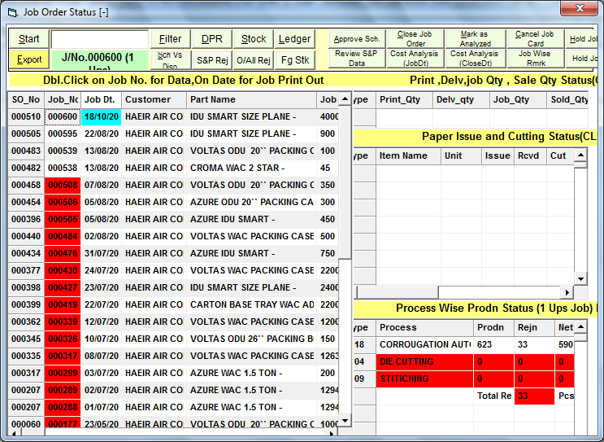

This production data is updated on all screens as show above

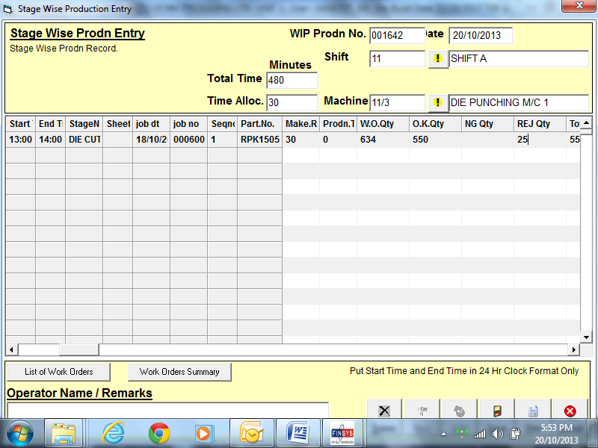

Die cutting entry
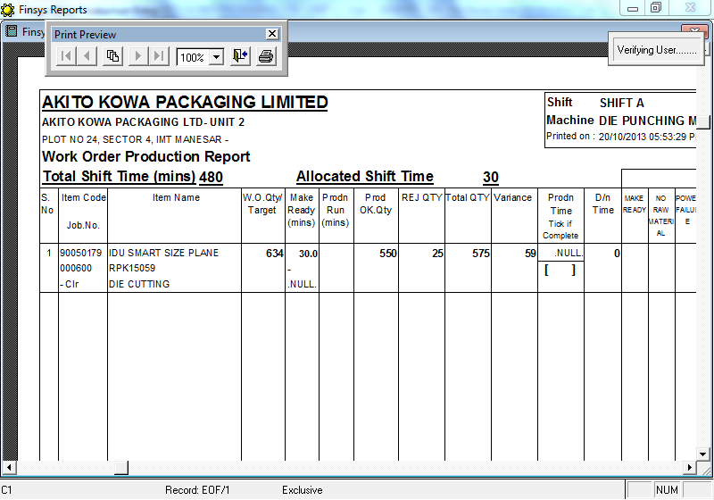

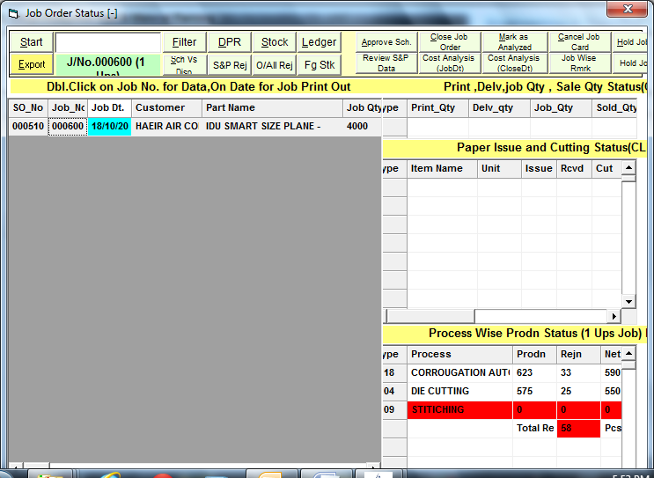

Updated die cutting also

Now for last stage, stitching

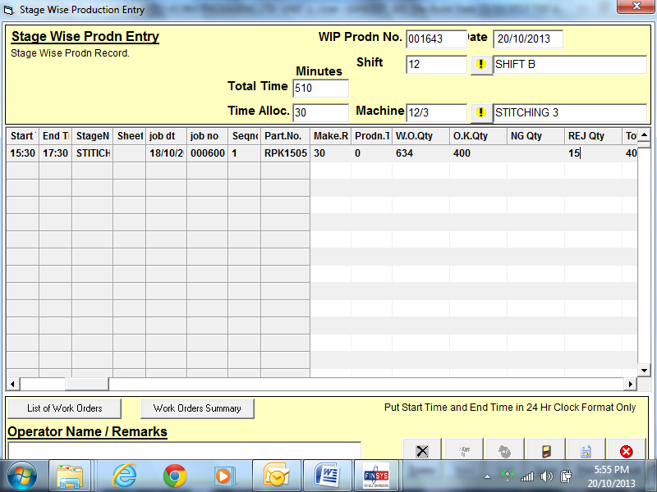
Stitching entry

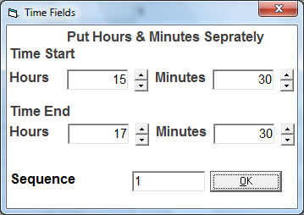

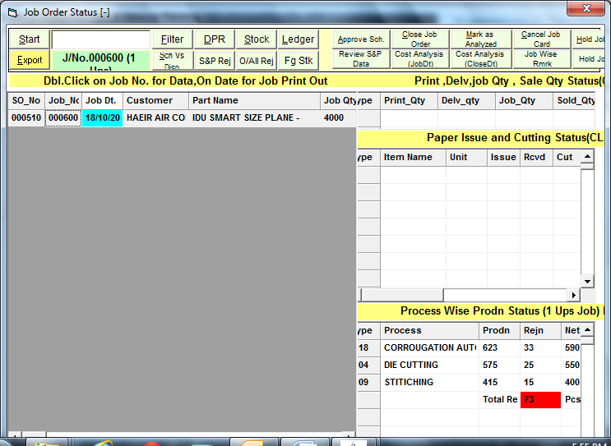

Shows the WIP at each stage
Shows the rejection at each stage

And total rejection

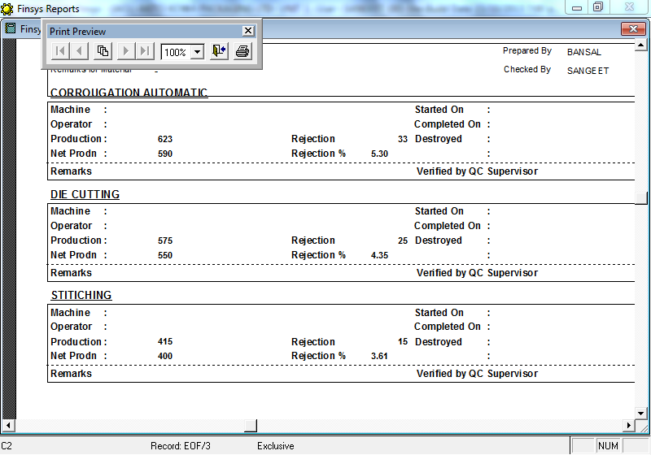
The job card is also updated
With rejection at each stage

And rejection percent

Finally

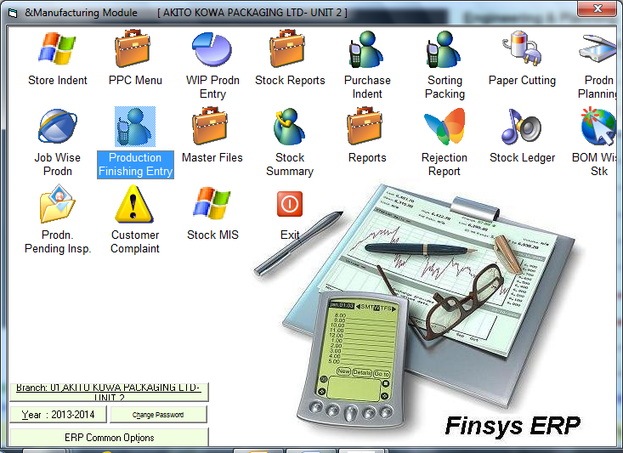

And then shipment
Invoice, is as usual

Then an auto email for invoice

From: finsysmail@democompany.co.in
Sent: Sunday, October 20, 2013
To: skgupta@abcd.com
Subject: New Invoice No.005296 By SURESH

DEMO COMPANY LIMITED
PLOT NO 113, SECTOR-3, IMT MANESAR, GURGAON,
Invoice Creation Auto-E-Mail

Sir,
This is to advice that the following shipment is being despatched from our factory as follows.
Invoice.No | Dated | Items | Rate. | Quantity | Part No.
005296 | 27/07/2013 | CORRU BOX W06673E 001 | 5.60 | 3500 | pk-57
Information
Customer : STERLITE ELECTRONICS LIMITED
Invoice Created on : 7:17:51 .PM
Invoice Total Amt. : Rs.19992 .
Road Permit no -
ST 38 - 00058631

Transporter tracking details
Goods Dispatch Thru : By Road HR38J-4593 .
Transporter Name : Jaipur Golden Transport Ltd,
GR no 54841, dated 24/07/2013,
Driver name – Satinder Singh,
Driver mobile no 9811549181
Note
This Report is Auto generated from the ERP.
This Report is based on the data entered . And if it does not tally with your existing knowledge of the actual events - Please get the data updated in the system.
Generated from Finsys ERP ... from the computer of “SURESH” at 7:27 pm

Mission successful

