Automatic Corrugation Plant – Manual for Finsys ERP
Part 1 : Sales Module

In this demo, we show you an Automatic corrugation plant’s manufacturing activities

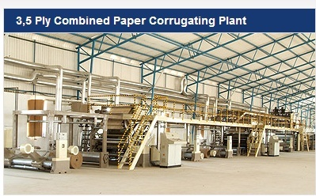

In this Screenshot based cycle, we will show the Manufacturing process activities

- Part 1 : Sales order , Sales Schedule, Order Acceptance , Order online Approval
- Part 2 : Sales order , Sales Schedule, Order Acceptance , Order online Approval
- Part 3 : Sales order , Sales Schedule, Order Acceptance , Order online Approval
- Part 4 : Sales order , Sales Schedule, Order Acceptance , Order online Approval
- Part 5 : Sales order , Sales Schedule, Order Acceptance , Order online Approval

First screen in Web mode

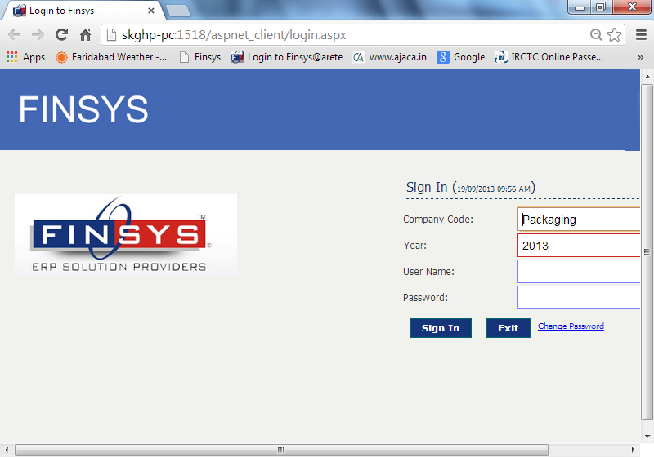

First screen in Client Server mode

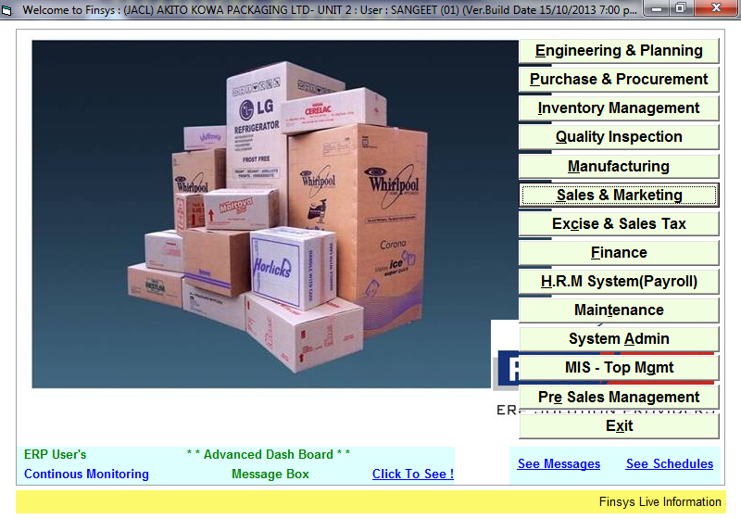

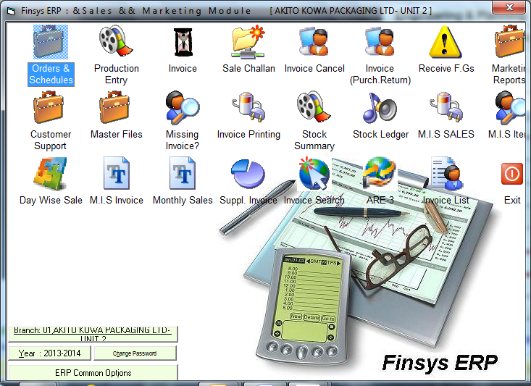
First screen for the orders and schedule entry

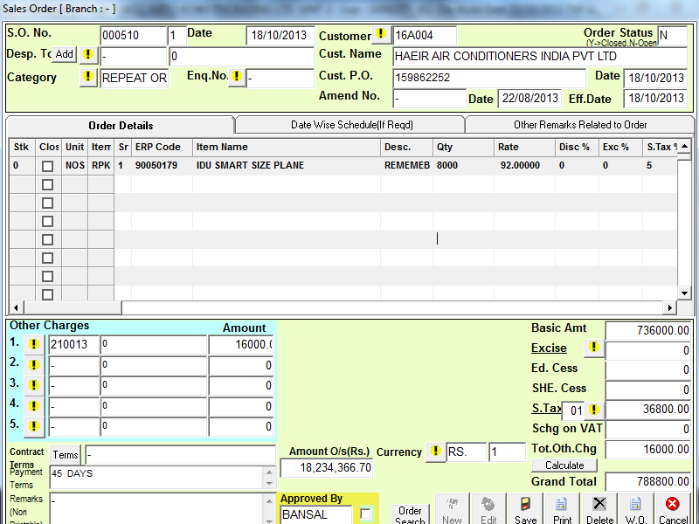

In this screen, we are entering a new “order” from a customer
Shows current outstanding also
and when system asks, we give additional information as under

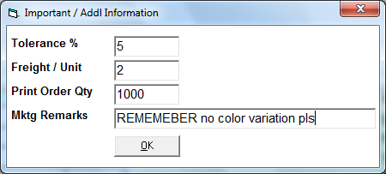

Marketing team input

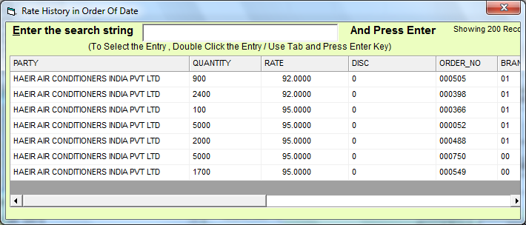
Past price history comes automatically

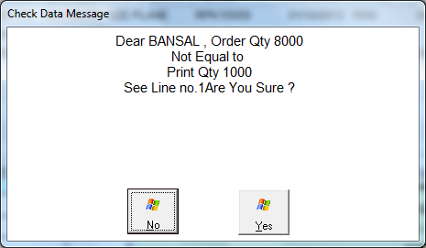

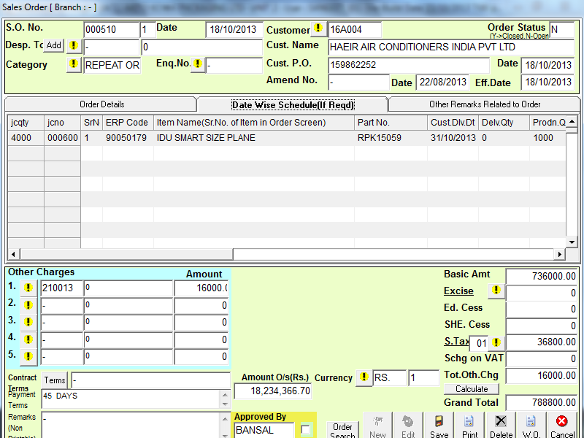

Here is the schedule for 1000 nos

When you press save

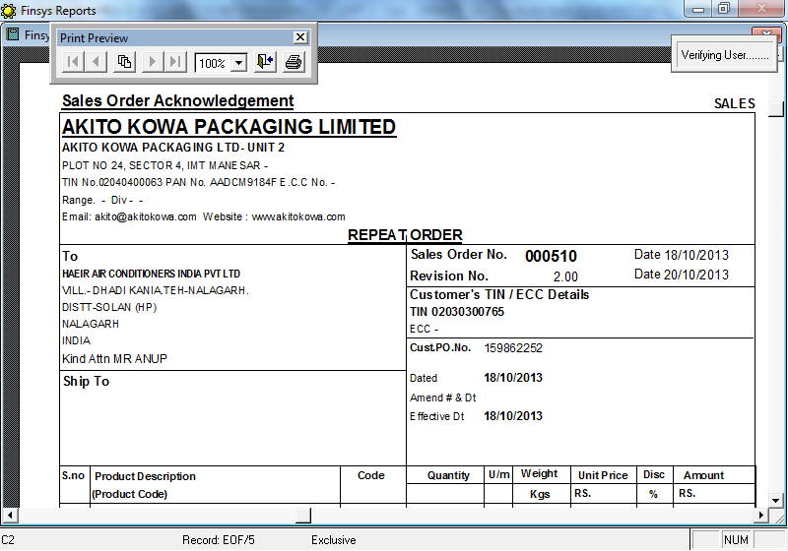

The Order Acknowledgment is printed ( upper half )

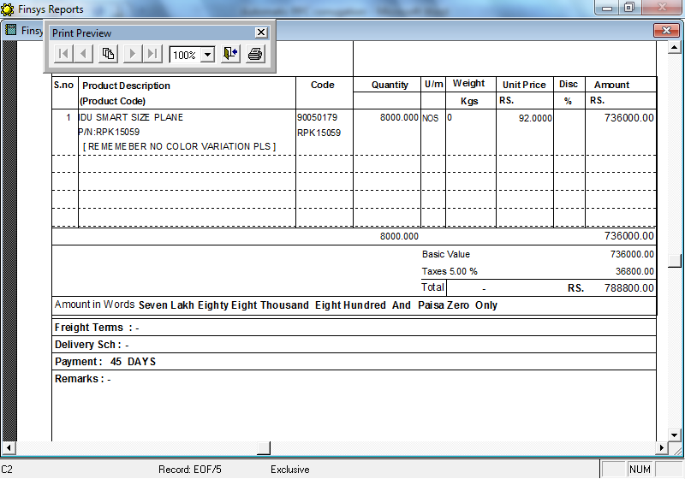

Lower half

Now the Order has to be approved

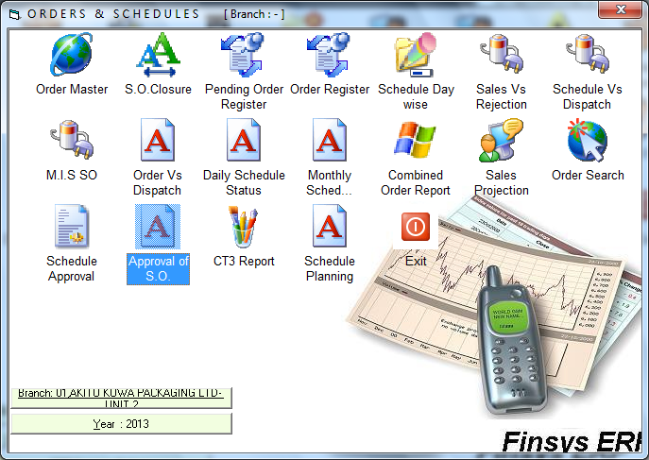
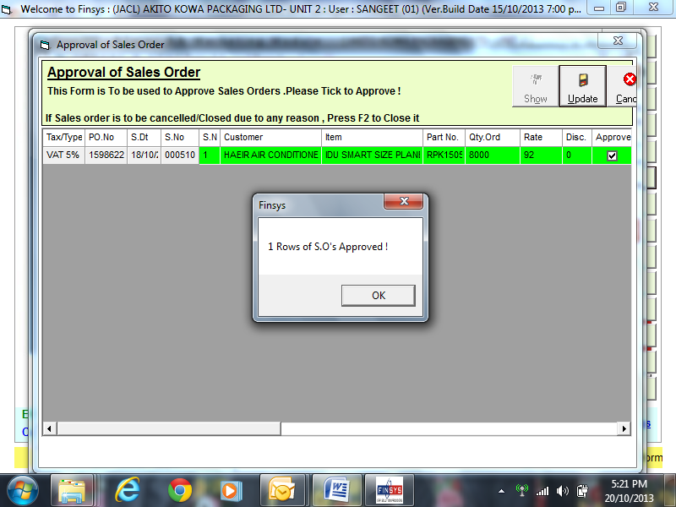

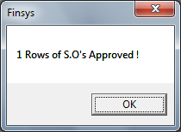

Now, over to second slide

