Costing comparison while making Process Plan ( one time , during initial standard, most efficient plan)
And later,
See the exact cost now, based on current paper selection at Job Card stage also
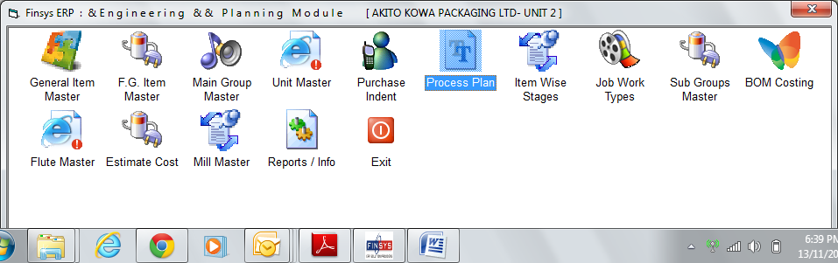

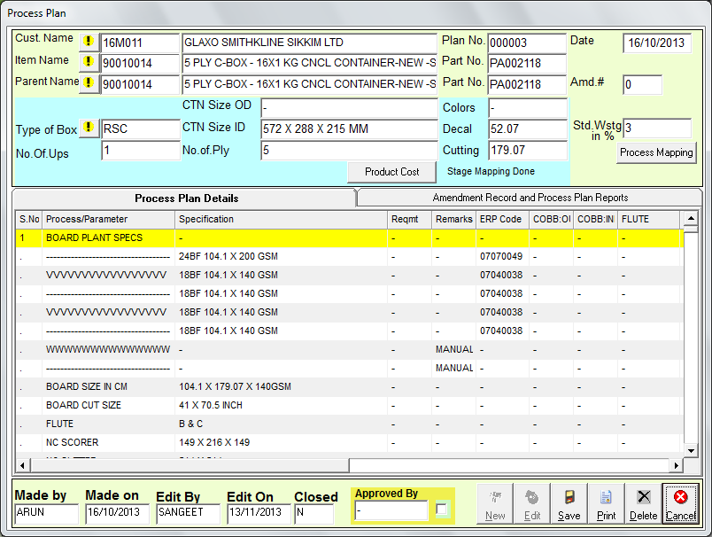
I make this above linkage of paper for layers and flutes
As soon as I press save,
System alerts me
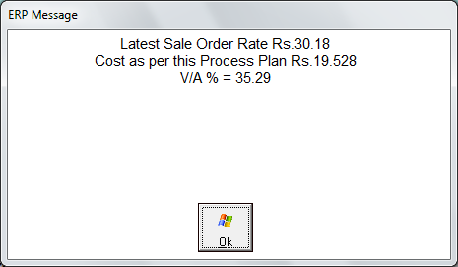

V/A = value addition Percent is 35%

Now,
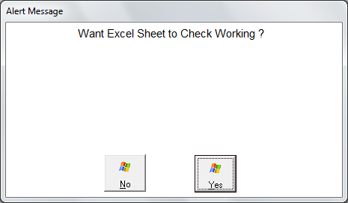
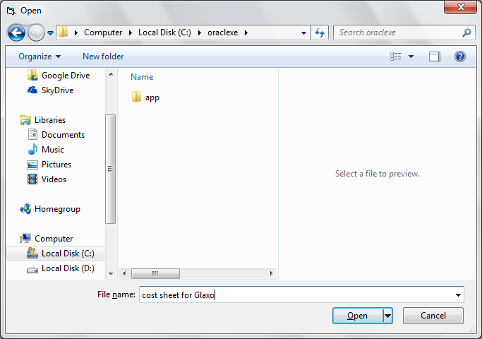
We save it in excel
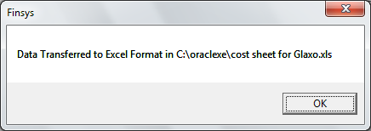

It says, ok saved
All calculations were automatic

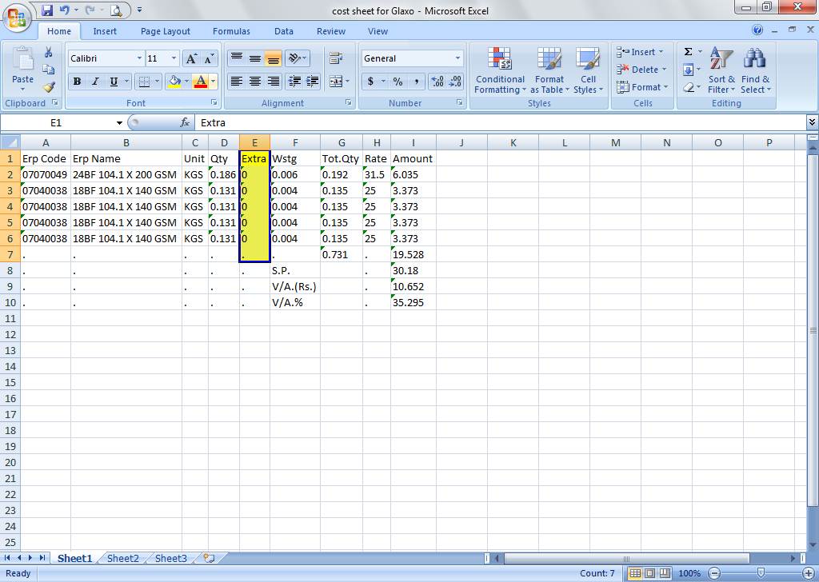

Calculation sheet is ready
But note, it shows the extra colm as ZERO
Reason = we did not specify the Fluting pattern is E or C or what ?

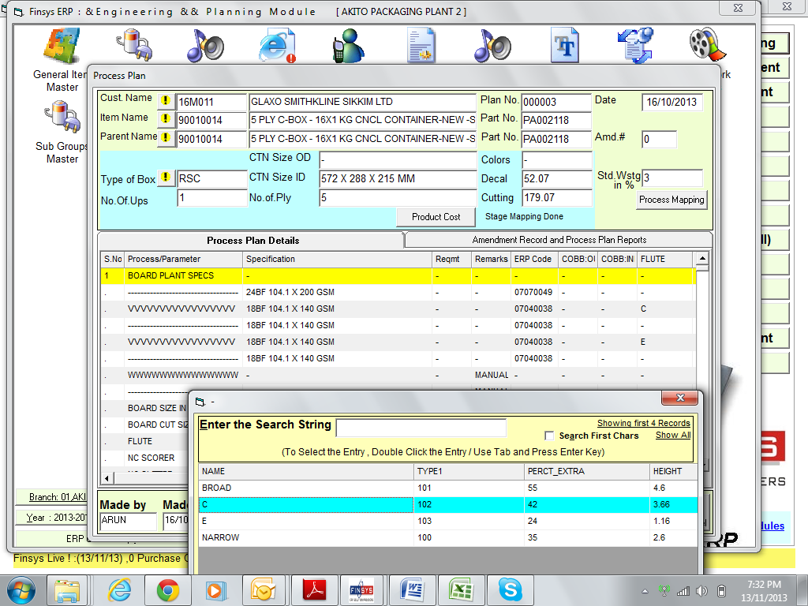

Now we click at flute colm
And select C flute , with 42% extra for this layer

And for experiment sake, we select E fluting with 24% extra in 2nd fluting ( 4th paper )

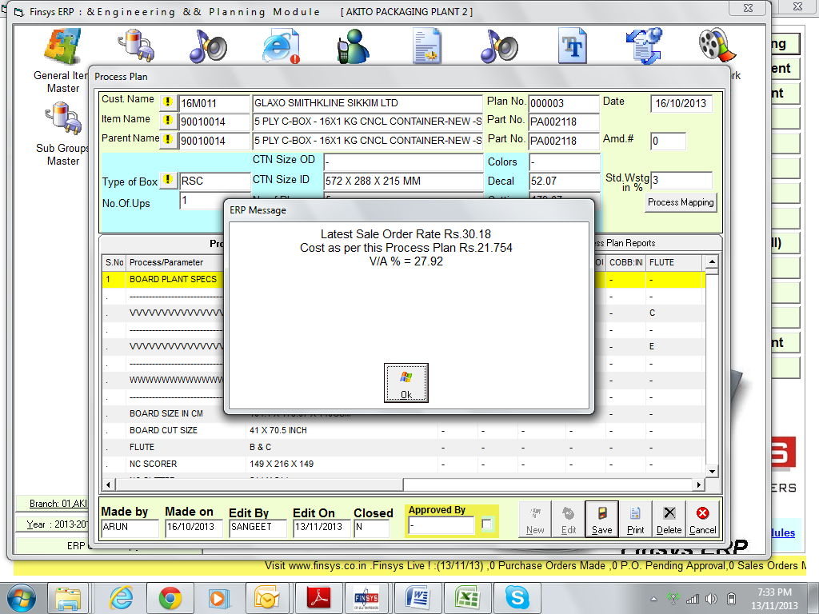

Immediately the system alerts, that cost has risen to Rs 21.754
And VA has dropped to 27.92% ( earlier it was 35.29% )

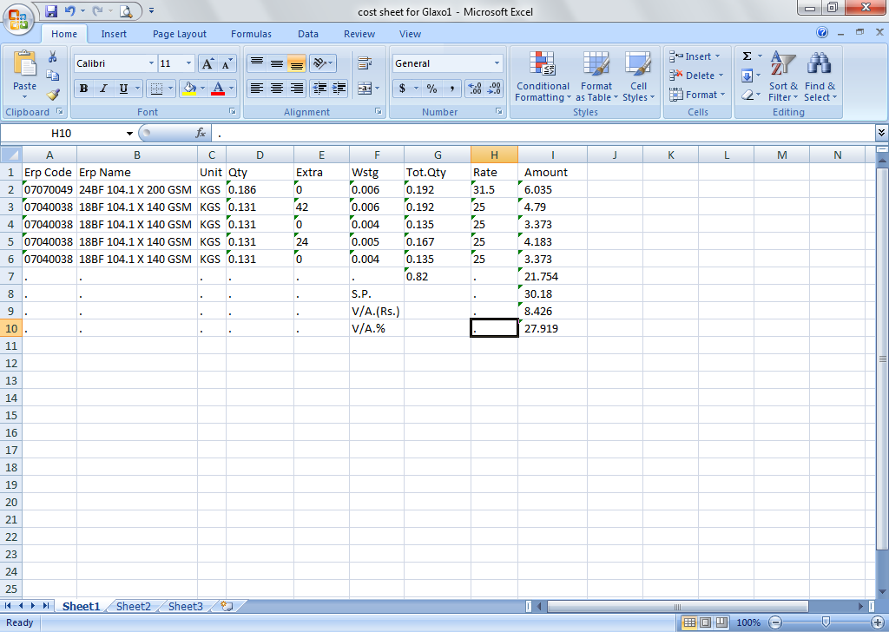

This working is also seen
And is automatic and is ok

Now we will see this cost, again when we make the job card

