Stock entries

Year End entries

Closing Stock entries

Closing stock entry in last date of previous year

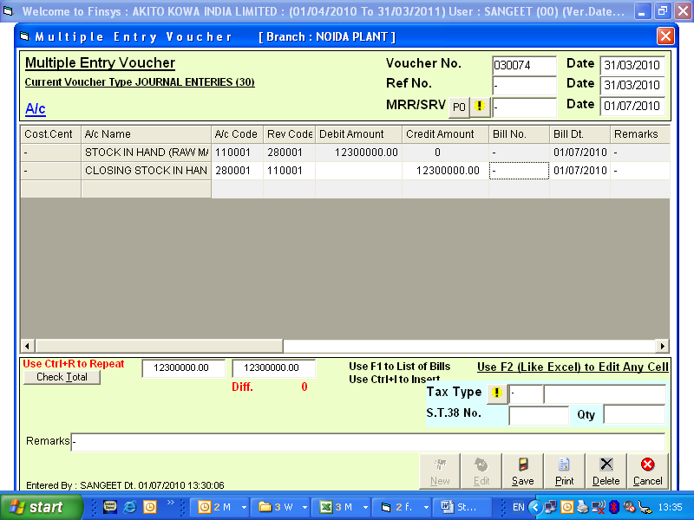

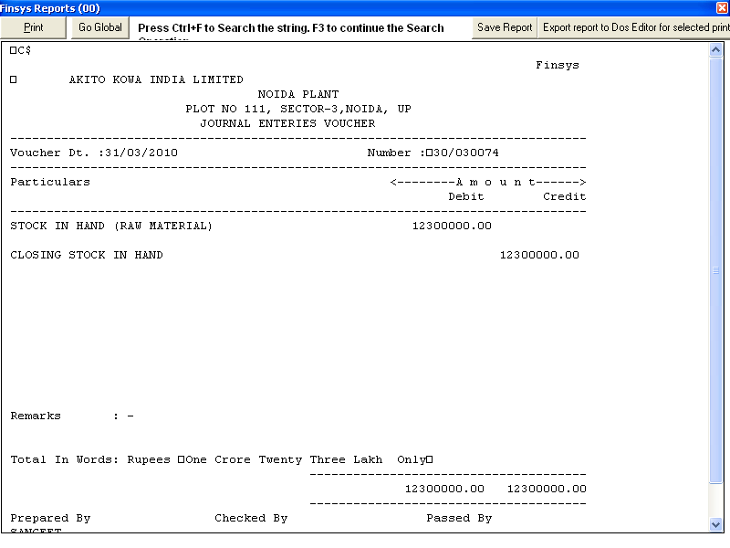

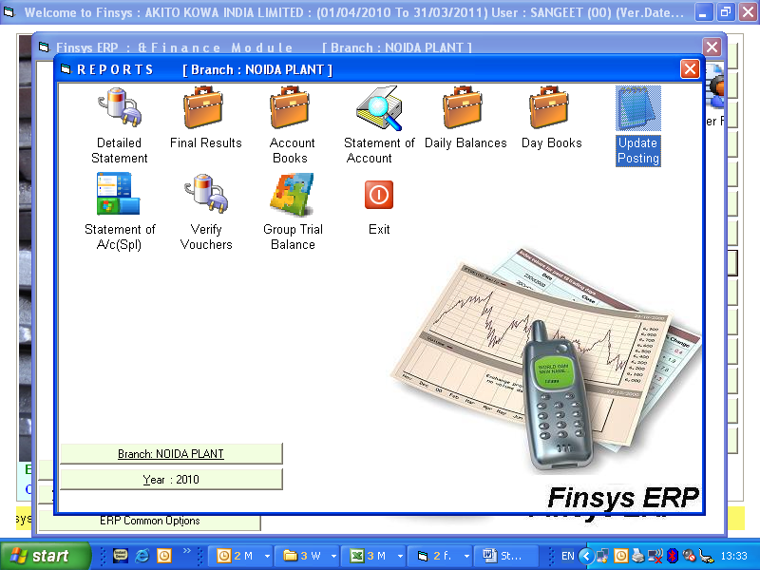

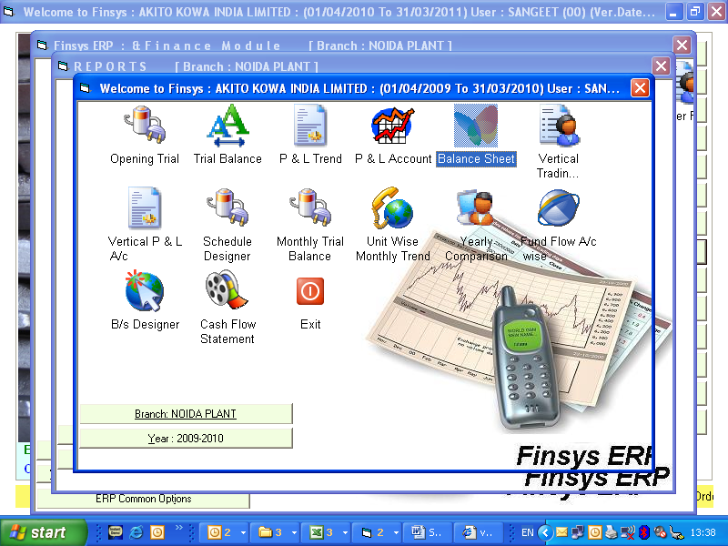
See the balance sheet

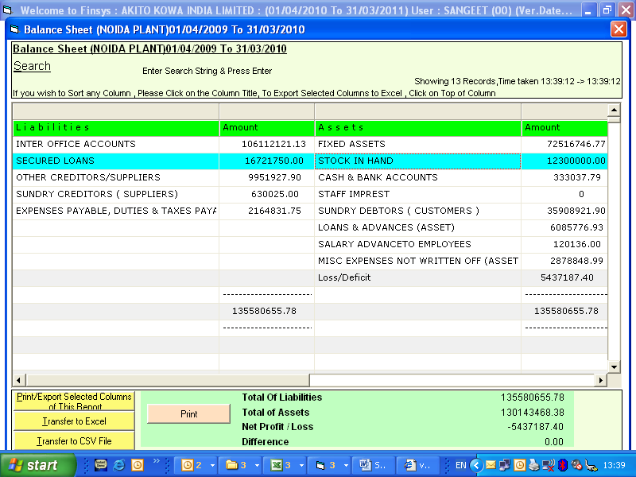

Now go to next year
update posting to bring over the opening stock balance from previous year to this year.
You can see the opening stock in the next year opening trial balance
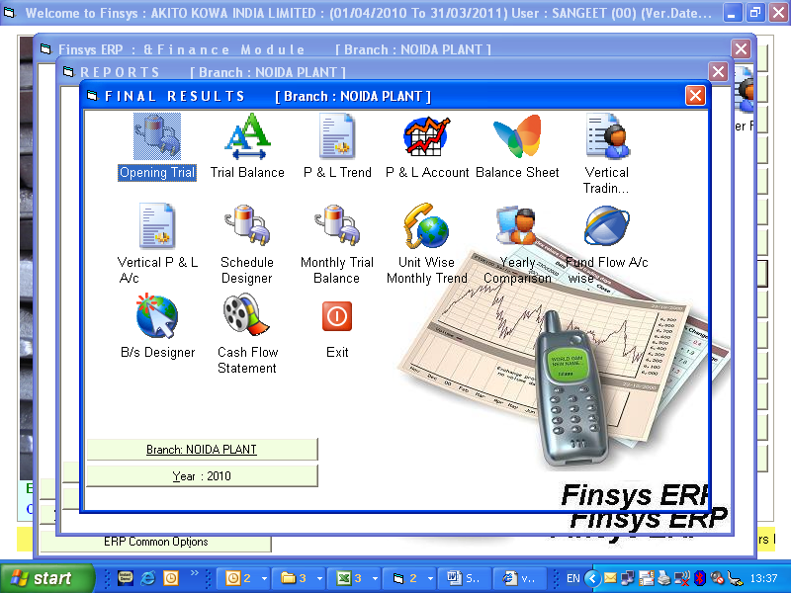
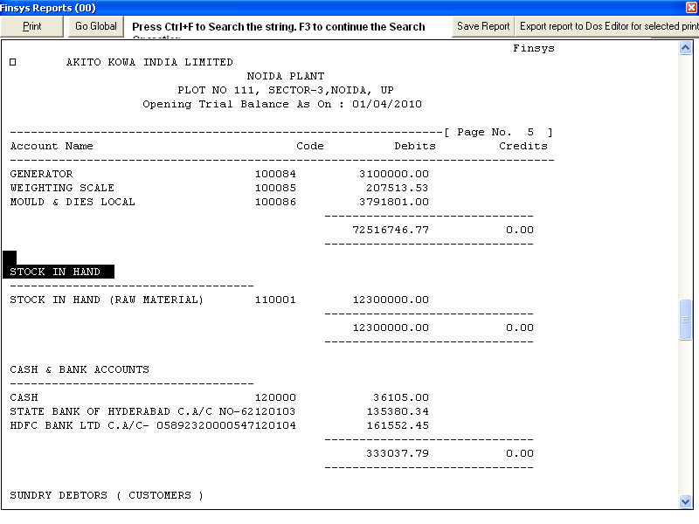
Stock in hand is now a asset = for Rs 1.23 crores

Now year change and reversal entry

290001 | Opening Stock(P & L) |  |  | Dr | 1.23 crores
110001, | To Stock in Hand |  |  |  |  | 1.23 crores
 | ( for previous year stock taken to current year material consumption )
 | software angle
 | a) Opening Stock must be opened in 29 series
 |  | This is a Debit to the P & L
 |  | and this helps get correct increase/decrease in stock
 | case 1 | if you want to show as inc/dec in stock,
 |  | you can use any group 26 to 29 for this
 | case 2 | if you want to show as net in material consumption
 |  | you can use any group "30" for this
 | b) Stock in hand
 |  | this entry will adjust the opening entry, to ZERO
 |  | The opening stock that was coming in 110001
 |  | will become zero with this entry
 |  | and this figure will be tfr to the profit and loss – trading account
 | This is a JV
 | Must be entered accordingly in "Quick Voucher" menu option

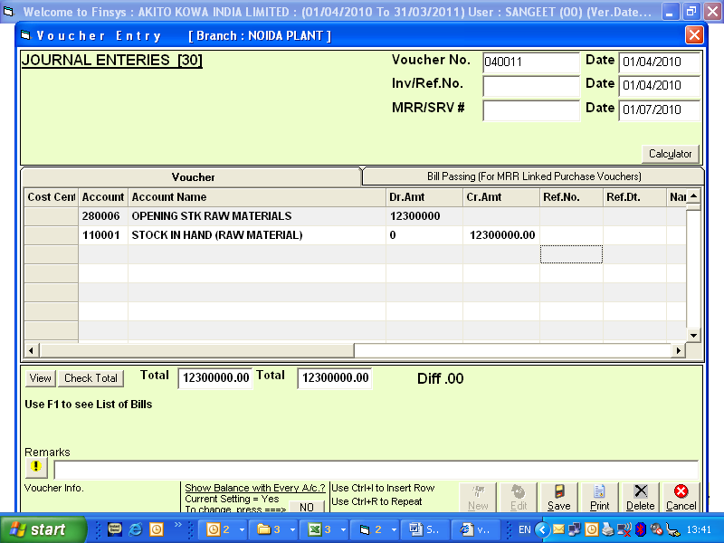

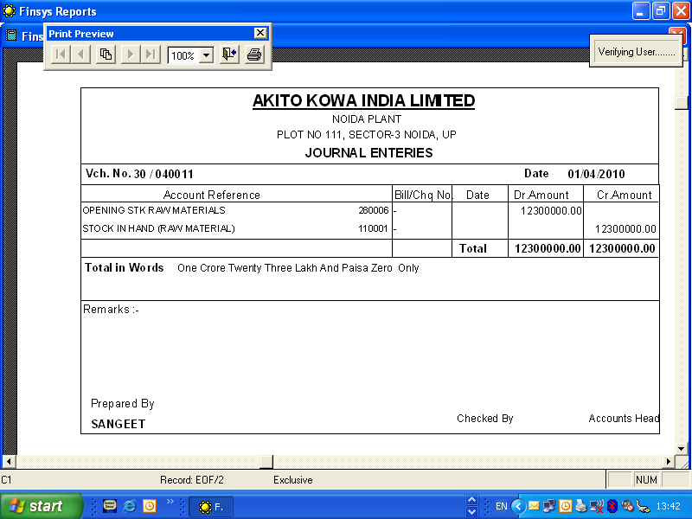

Now the closing stock of 30.6.2010

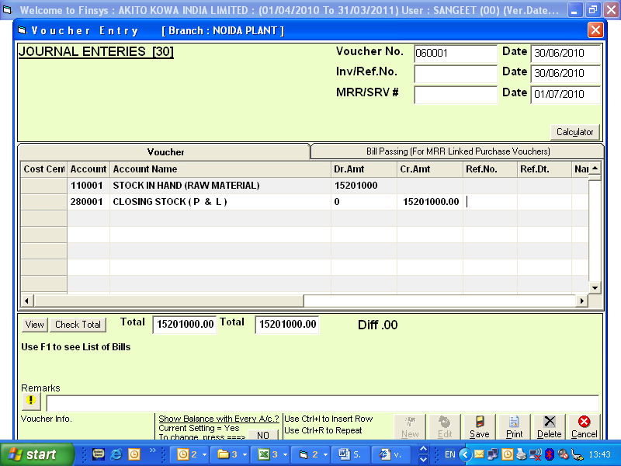

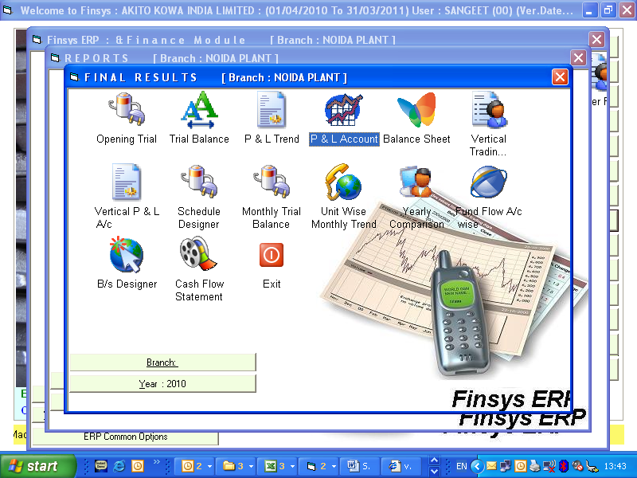

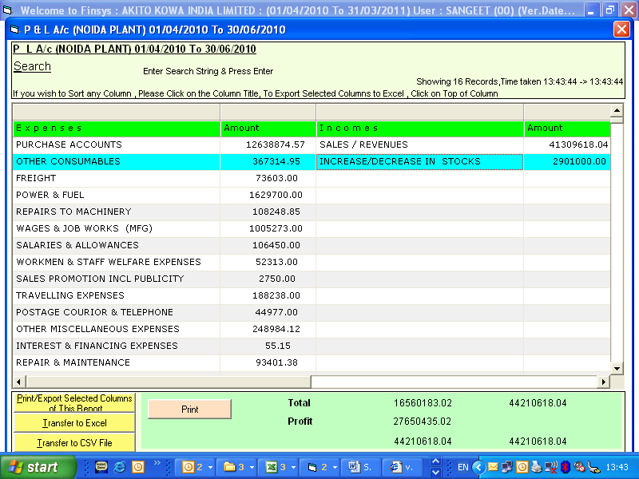
This is perfect way of opening and closing stock entries
For additional info : Pls contact our Director, Mr Sangeet Gupta 9312608426 skgupta@finsys.in

Writeup

 | example
110001 | Stock in Hand |  |  | Dr | 10000
290002 | To Closing Stock ( P & L ) |  |  |  |  | 10000
 | ( for current year stock taken to current year material consumption )
 | software angle
 | a) Closing Stock must be opened in 29 series
 |  | This is a Credit to the P & L
 |  | and this helps get correct increase/decrease in stock
 | case 1 | if you want to show as inc/dec in stock,
 |  | you can use any group 26 to 29 for this
 | case 2 | if you want to show as net in material consumption
 |  | you can use any group "30" for this
 | b) Stock in hand
 |  | this is a Asset (Current Asset), to be carried forward to next year
 |  | ( it must be opened in the 11 series only)
 | This is a JV
 | Must be entered accordingly in "Quick Voucher" menu option

