Finance – Vouchers – Multiple Vouchers

The Finsys has the option of Multiple bill Voucher also, with facility of selecting multiple bills at one time, during Receipt or payment.

Multi Bill Receipt / Payment Voucher

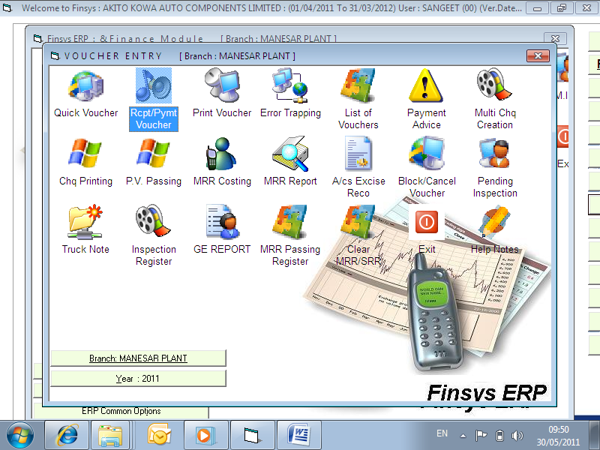

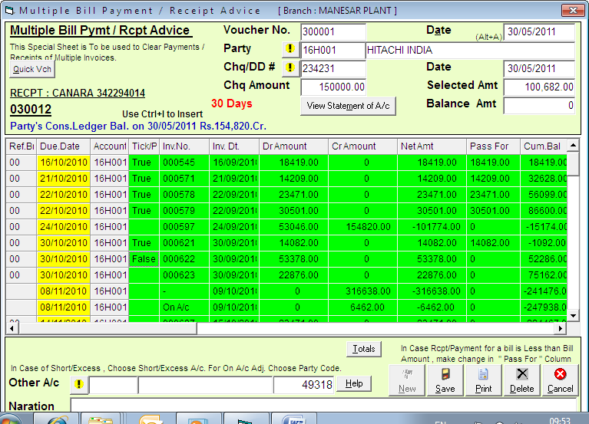

Just enter the amount at the Top

And Tick “True” to the Bills you have to adjust against this cheque
Bill Date , Bill no and amount of these bills is shown
Due date of these bills is in First Colm
-- also shown is the Bill wise payment already received if any | “Credit Colm”
There is also a facility to “Pass a bill for a lower amount” , if applicable

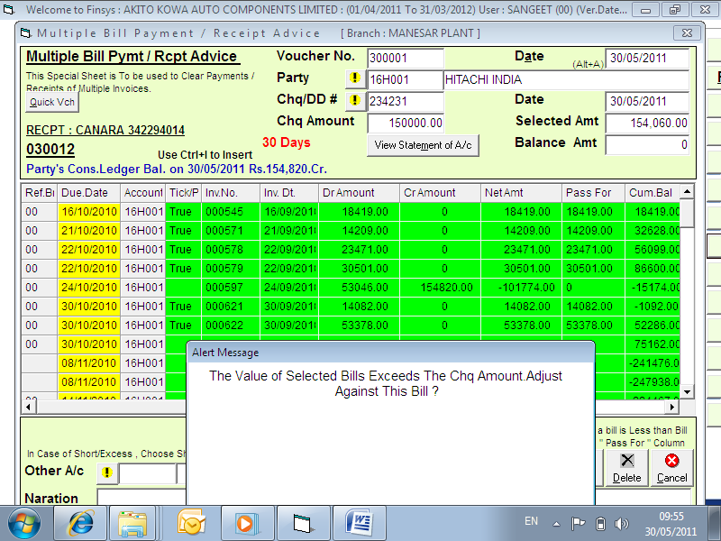
Chq is for 150,000, but bills selected higher amt.

If the amount of cheque is less than the amount of Bills selected → it alarms and also helps in case , you want a FIFO adjustment ( First against the oldest bills, and finally lastly against the last bill ).
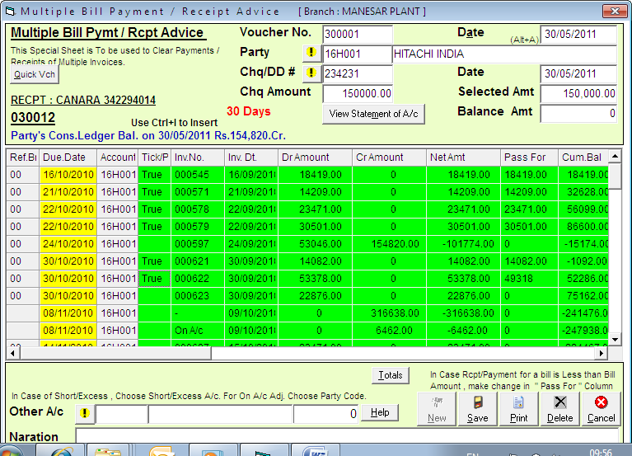
Amount is net off to Rs 150000
Adjusted in Last bill, if you do not have bill wise breakup.

Green is for bills that are due for payment
WHITE IS ==> for bills not yet due

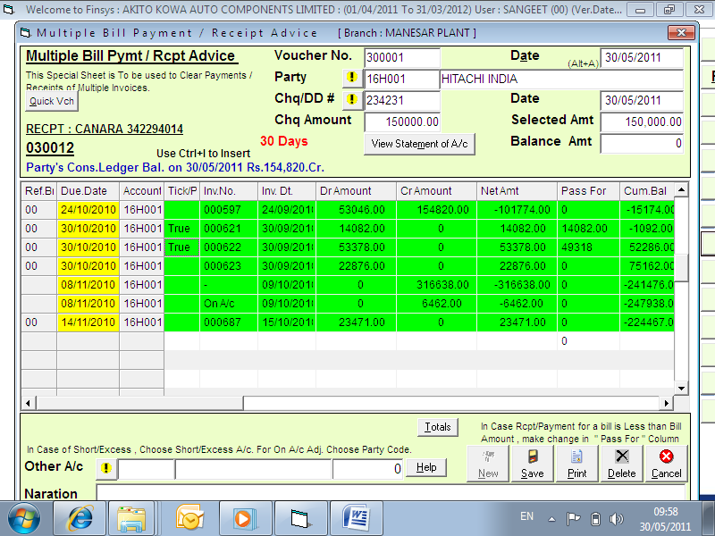
Other account = used for Bank charges, rebate and discount etc in this payment

You can also, adjust the Bank Charges or DD charges via the bottom other account button.

You can also, Write off the deductions by the customer ➔ via the bottom other account button.

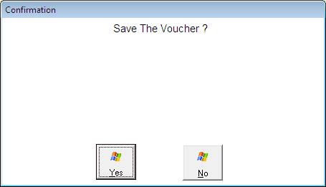

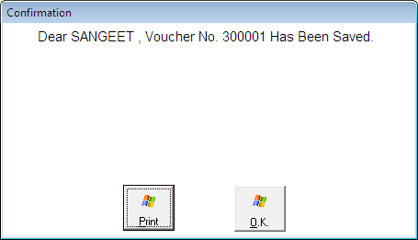

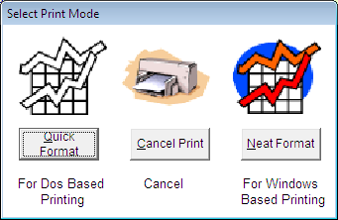

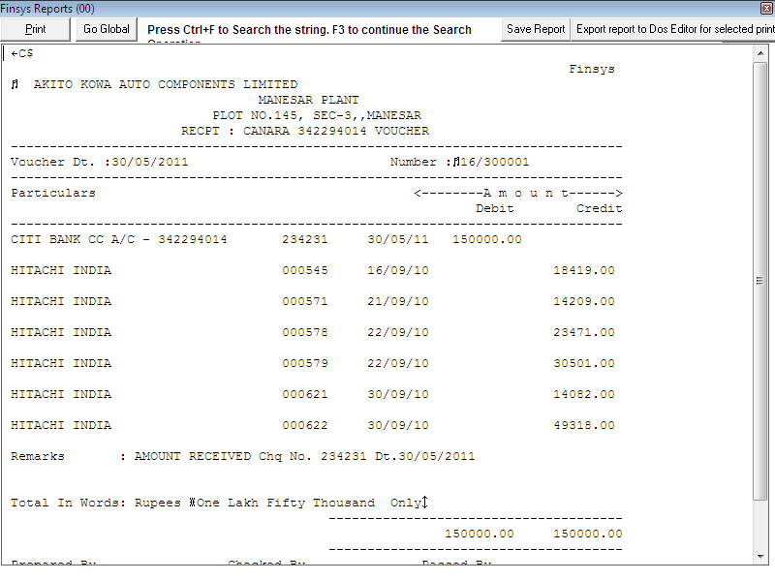
Ready
Done

